Dedicated to finding Vauter(s), Vawter(s), Vaughter(s)
Newsletter
March 2018 Volume 42 No1
Reunion Dates:
Madison Indiana July 19-21, 2018
Topeka Kansas July 2019
Vauter’sChurch, Virginia 2020

Website: www.vawterfamily.org
Officers
President Darren Welch, 402 N Galeston Ave, Indianapolis, IN 46229
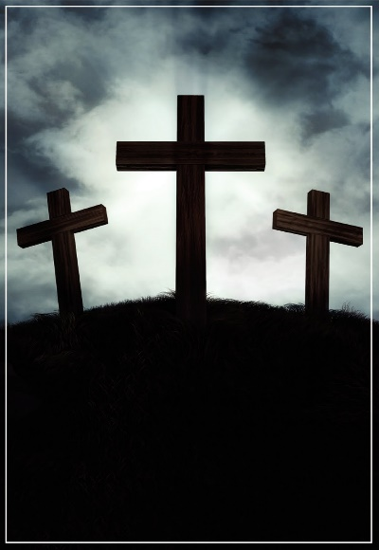 Phone 317-899-1992 email: Darren.welch@cnoinc.com
This Photo by Unknown Author is licensed under CC BY-NC-SA
Vice President Robert L. Vawter, 3773 Piper Bay Ln, Lakeland, TN 38002
vawter.bob@gmail.com
Treasurer Jordan M. Johnston…2450 Bear Creek Road
Pipe Creek, TX 78063 Phone - 903-624-9632
Email – jjohnston3200@gmail.com
Asst. Treasurer Phil Vaughter…1103 Newport, Austin, TX 78753
Phone…512-836-3105 email - PRV37@aol.com
Secretary Michelle Alexander.. 489 Nannie Neal Rd, Hardin, KY 42048
Email - mrax3@juno.com
Archivist Beth Melton… 3809 Junker, Rosenberg, TX 77471
Phone - 281-232-7972 email - emeltonea@aol.com
Newsletter & Georgene Jurgensen…8408 Mohican Ave
Genealogist Brooksville, FL 34613
Phone…816-591-0251 email - gfjurgensen@gmail.com
Website & Patricia Renton…2372 Bear Creek Rd, Pipe Creek, TX 78063
Newsletter Phone…830-510-4625 email - pvrenton@gmail.com

As in 1982, we are staying at Clifty Falls State Park, where rooms have been booked at the Clifty Inn. The
inn is located just off the south entrance of the park, and is about two miles from the historic district of Madison. A variety of rooms are booked for July 19 - 21. Because some people may want to arrive early,
we have a few rooms for Wednesday, July 18. Applicable taxes will be added to all rates.

Parkside, One queen bed, ADA
July 19, $111.99; July 20, $134.99; July 21, $134.99

Parkside, Two queens beds
July 18, $111.99; July 19, $111.99; July 20, $134.99; July 21, $134.99

Riverview, Two queen beds
July 18, $121.99; July 19, $121.99; July 20, $149.99; July 21, $149.99

Riverview, Two queen beds, ADA
July 18, $121.99; July 19, $121.99; July 20, $149.99; July 21, $149.99

Riverview, Two queen beds, Balcony
July 19, $131.99; July 20, $159.99; July 21, $159.99

Riverview, Two queen beds, Patio
July 18, $131.99; July 19, $131.99; July 20, $159.99; July 21, $159.99

To make reservations, go online at www.Indianainns.com or call toll free 1-877-563-4371.
When making a reservation, don’t forget to give our code #0717VF.

In Memoriam

Evelyn M. Vawter, 96, of Louisa passed away Monday, January 22, 2018 at English Meadows Assisted Living.
Mrs. Vawter was a lifelong resident of Louisa. She was a member of Louisa Christian Church. Mrs. Vawter was preceded in death by her husband, Reid W. Vawter; and daughter-in-law Nancy Vawter.
Survivors include two sons, Fred Vawter of Richmond and Harold Vawter of Louisa; brother Johnny Manino of Louisiana; and grandchildren Kyle, Van, Lisa, Susan, Jason and Tiffany; and several great-grandchildren.

Marvin Edwin Vawter, Jr., 62, of St. Cloud, FL passed away on November 12, 2017. He was born on February 5, 1955 to Marvin and Connie (Kennedy) Vawter in Cincinnati, OH. He was Veteran of the United States Air-Force serving during the Vietnam War; he was also a member of the Blue Knights Drill Team. He was a truck driver during his working years. Marvin is survived by his loving family, wife of 12 years, Sue A. Vawter of St. Cloud, FL and his Mother, Connie Laverne Kennedy of Dayton, KY; sisters, Sandra Adams of Fort Thomas, KY, Monique R. Corbett of Erlanger, KY; brother, Michael (Rachel) Vawter of Hamilton, OH. He was preceded in death by his Father, Marvin E. Vawter, Sr. and brothers Stephen Vawter and Jeff Vawter.

Obituary for Alan Clark Vaughter
Mr. Alan Clark Vaughter, 71, went from his earthly home to his heavenly home, January 10th, 2018.
Alan loved Jesus first and was always ready to tell others about his Savior. His second love was his wife, son, daughter and grandchildren, but he just loved people in general. He also greatly enjoyed working with young people teaching tennis and most importantly teaching them about Scripture. Alan was born in Elbert County, August 10th, 1946 to the late Tate and Gussie Vaughter.
He is survived by his wife, Beth Berryman Vaughter, son and wife, Kevin and Leyna Vaughter, daughter and husband, Jill and Adam Raulerson and six grandchildren: Braeden, Molly and Reed Vaughter and Will, Carter and Abby Raulerson. Alan is also survived by two sisters, Barbara Kay and Susan Jordan, and one brother, Richard Vaughter. He is also survived by in-laws Marilyn Heard (Charles), Wendell Berryman (Patti), Faine Berryman (Betty), Joy Jordan (John), Robert McMurray and Peggy Berryman.

Page 2

In Memoriam

Deborah Jean Taylor, 64, of Hudson, Kentucky, passed away Tuesday, January 9, 2018, at Hardin County Memorial Hospital in Elizabethtown, Kentucky.
Born January 31, 1953, in Seymour, Indiana, Deborah was the daughter of Roy Taylor Jr. and Helen Walt Taylor. She graduated from Jennings County High School in 1971, and earned a bachelor’s degree in elementary education from Indiana University. She retired as a quality editor from Answers. com.

Deborah is survived by her mother, Helen Walt Taylor of North Vernon, Indiana; a brother, James Daniel Taylor of North Vernon; a sister, Cynthia Bonham of Crestview, Florida; a niece Lucynda Burton of Largo, Florida; an uncle, Tom Taylor of North Vernon; and an aunt, Bonita Welch of Scipio, Indiana.

Preceding her in death were her father; a brother, Donald Robert Taylor; and a nephew, Benjamin Brand Burton.

Maxine Marie Joling, age 94, of Wisconsin Rapids, passed away Wednesday, November 29, 2017 at Three Oaks in Marshfield, WI.
Maxine was born June 19, 1923 in Lexington, Illinois to Skyler and Florence (Turnham) Vawter. She married Evert Joling on March 27, 1945 in Vesper, WI. He preceded her in death on November 20, 2005.

Maxine was a lifelong Registered Nurse. She graduated from Presbyterian Hospital in Chicago, Illinois and went on to work at an Army hospital as a cadet nurse. After her children were born, she returned to work as a nurse at Riverview Hospital and later as a public health nurse.

Maxine enjoyed doing genealogy, traveling, sewing, and gardening. Her greatest joy was spending time with her grandchildren. Maxine loved the Lord. She had an unwavering trust in His provisions.

Maxine is survived by four children: Patricia (William) Cook, Holton, MI, Judith (Jerry) Aue, Hudson, WI, Priscilla (Dale) Aue, Auburndale, WI, and Peter (Mary) Joling, Wisconsin Rapids, WI; 10 grandchildren: Bill (Theresa) Cook, Jeannine (Josh) Escobedo, Jeffery (deceased) (Tiffany) Aue, Larry (Jennifer) Aue, Sarah (Andy) Palodichuk, Juli (Joe) Norby, Dale (Kelly) Aue, Melisa Schertz (Phil Rust), Johnathon (Christa) Joling, James (Tiffany) Joling, and Jordan (Brittni) Joling; 26 great-grandchildren; and one sister, Josephine Parker, Indianapolis, IN.

She is preceded in death by her parents, husband, Evert, two children, Charles and Catherine, one sister and four brothers.
Page 3

In Memoriam

Vernon Milton Pickett, 91, of Noblesville, Indiana, passed away Wednesday, February 7,
2018, at Riverview Hospital in Noblesville.

Born October 19, 1926, in Jennings County, Indiana, Mr. Pickett was the son of Alva and Bertha Wilson Pickett. He married Charlotte Harding on June 24, 1949, in North Vernon, Indiana. She survives.

Mr. Pickett was a 1944 graduate of North Vernon High School and received an associate’s degree from Purdue University. He served in the U.S. Navy from December 1943 until June 1946, and worked as an industrial engineer for General Motors in Kokomo, Indiana, for 34 years.
He was a member of North Vernon Masonic Lodge #59, North Vernon Chapter #183 Order of the Eastern Star, York Rite of Indiana #104 in Kokomo, First Baptist Church of North Vernon, the Vawter-Vauter-Vaughter(s) Family Association, and a life member of the NRA. He enjoyed traveling, genealogy and spending time with his family.

Surviving with his wife, Charlotte, are sons, Larry Pickett and his wife, Maureen, of Kokomo and Gary Pickett of Bunker Hill, Indiana; daughters, Marilyn Gipson of Noblesville, Linda Randall and her husband, Dan, of Kokomo, Diana Stevens and her husband, Doug, of Springfield, Ohio, and Debbie Deisch and her husband, Mark, of Kempton, Indiana; grandchildren, Heather Cosier of Boston, Massachusetts, Ashley Coykendall and Joshua Pickett of Kokomo, Brad Stevens of New Carlisle, Ohio, Katy Ferrell of Springfield, Ohio, Jordan Pickett of Bunker Hill, Jennifer Pickett of Indianapolis, Amy Pickett of Avon, Indiana, Jarred Pickett of Longmont, Colorado, Heath Pickett of Rossville, Indiana, Darcey Deisch of Houston, Texas, Lauren Shelton of Kempton and Tanner Deisch of Greensboro, North Carolina; and ten great-grandchildren.

He was preceded in death by his parents; a daughter-in-law, Monica Pickett; five brothers, Dallas, Maurice, Denver, Ralph and Raymond Pickett; and two sisters, Neva Fendley and Nina Duckett.

Funeral services and a Masonic memorial service were held in North Vernon, Indiana,
at Dove-Sharp &Rudicel Funeral Home. Burial was in the Vernon Cemetery.
Milton and Charlotte attended many VVV reunions. Several members of their family
were with them for the 2007 reunion at Blackwater Falls State Park in West Virginia.

Page 4

2018 REUNION PLANS

As told in previous newsletters, the 2018 reunion of the VVV Family Association is to be held in Madison, Indiana, on July 19-21. Rooms have been reserved at the Clifty Inn, located in Clifty Falls State Park, just west of Downtown Madison.
Registration begins at 3 p.m. on Thursday, July 19, in The Overlook room.Those arriving before the 4 p.m. check-in time will be able to visit in that room or one of the many conversation areas of the inn. A few rooms have been reserved for Wednesday, and we already have two members who are arriving on Tuesday.
Friday begins with the opening meeting at 9 a.m. We hope to have a genealogy session immediately after the meeting. Because some people prefer free time instead of structured, we are leaving Friday open for you to browse the shops in Madison, perhaps research at the Jefferson County Public Library, relax along the Ohio River, do some hiking or swimming in the park, or simply stay at the inn and visit with other members and view the items on display. At 6 p.m., we will have a buffet dinner in The Overlook room.
Saturday will be a day for exploring the roots of the Vawter Family in Jennings County, about 20 miles north of Madison. Along the way, we plan to stop at Wirt Baptist Cemetery, where Rev. Jesse and Elizabeth Watts Vawter are buried. We will spend time in Vernon at the Vernon Cemetery and the Jennings County Historical Society, and then go to Selmier State Forest to see the Vawter-Summerfield Cemetery and the site of William and Frances Vawter’s home. From there we head back to Clifty Inn for a buffet dinner and the closing meeting.
Please do not delay making your reservations at the Clifty Inn. We have an early release of rooms date of May 20, and after that we cannot guarantee room availability or price. The inn is usually sold out.

IMPORTANT INFORMATION

If you make a reservation for a Parkside room and have a problem with stairs, be sure to request a ground floor room. There is no elevator in that section of the inn. The Riverview section does have elevators.

Clifty Falls is a popular state park, and the inn is usually sold out. The release date for our rooms is May 20, so do not delay making reservations. We cannot guarantee the availability of rooms or rates after that date. Cancellations can be made up to four days prior to the reservation. Check in time is 4 p.m. and check out is noon.
There is a one-time fee of $9.00 per car for out-of-state vehicles, and $7.00 per car for in-state. You are not required to pay each time entering the park after that.
For any questions, please contact Bonita Welch at bwelchbf@yahoo.com or on Facebook at Bonita Taylor Welch.
Page 5

VERNON, INDIANA

Vernon, Indiana, the county seat of Jennings County, was platted in 1815 by John Vawter, the son of Jesse and Elizabeth Watts Vawter. He first saw the area when a United States Surveyor for the Northwest Territory.

It was a planned town, with spaces set aside for schools, churches and recreation. A portion of the proceeds from the sale of each lot was used to finance a county library. Because of being almost surrounded by the Muscatatuck River, the town has not grown, and has the distinction of being the smallest county seat in Indiana.

An elevated railroad and underpass were the first west of the Alleghenies. The track, which was laid from Madison to Vernon was finished in 1838, and is still in use. Other “firsts” were the first public playground and the first trial with an all-women jury in Indiana. The Clionian Club, organized in the 1850s, remains active in the community.
John Vawter helped establish Vernon Baptist Church in April 1816, and served as pastor for several years. He left Vernon in 1848 for Morgan County, Indiana, where he was one of the first settlers of Morgantown. Although there is a monument for him in the Vernon Cemetery, he died 17 August 1862 in Morgantown and is buried in that town.

Several other members of the Vawter family were also prominent early citizens of Vernon. Smith Vawter, a son of John, was a pork packer, a dry goods merchant, and had woolen and flour mills. His home is still standing in Vernon. Achilles Vawter, a brother of John, was a tavern keeper and postmaster.
During the Civil War era, the town was an important Underground Railroad depot. A place near the river where militia and Vernon townspeople repelled General John Hunt Morgan’s raiders represents the northernmost penetration of the Confederate Army into Indiana.

The original town charter decreed elections for Vernon’s offices would be conducted every two years on the first Monday in March. Because the charter was filed one year before Indiana became a state, it is the only town in Indiana legally allowed to hold elections at a different time than the rest of the state. There is no primary, any number of candidates can file, and residents don’t have to register to vote. For the 2017 election, the incumbents were the only ones to declare their candidacy, with all of them running on the Citizens ticket. The town marshal and town clerk each received 26 votes, and the mayor followed with 25 votes. They also have elections for county, state and national offices on the same calendar as the rest of the state.
What started as a project in the mid 1970s by the Junior Historical Society at Jennings County High School, led to the town being registered on the National Register of Historic Places.

Page 6

VAWTER-SUMMERFIELD CEMETERY

Now known as the Vawter-Summerfield Cemetery, one of the oldest cemeteries in Jennings County, Indiana, was established by William Vawter on his property not long after moving to the county in 1829.
Although not the earliest death date recorded in the cemetery, the first burial was probably that of Jesse Vawter Burns, the grandson of William and his wife, Frances. Jesse was the son of Maxa Moncrief and Maria Vawter Burns, and died 12 March 1831 at the age of nine months and three days. Another grandson, Vawter Stott, died 12 March 1835 when he was two years, ten months and five days, and is also buried there. Vawter was the son of John and Elizabeth Vawter Stott.
Maria Vawter Burns died 7 Dec 1846, and is buried beside her son, Jesse. On her monument is found this inscription:
In memory of Maria, consort of M. M. Burns, who was born Dec 16, 1809, married Dec 16, 1828, and died Dec 7, 1846, aged 36 years, 11 months & 21 days. She left a husband and 7 children, father and mother, 6 brothers and 3 sisters to mourn her loss. She was the daughter of Wm & Frances Vawter. Meekly she bore in faith and hope, Her Heavenly fathers rod, and passed from trouble here below, to endless peace with God.
The earliest death date on a monument is 15 Apr 1814. It marks the grave of Philemon Vawter, who was first buried near Madison, Indiana, and later reinterred in the Vawter Cemetery. He and his wife, Anna, were the parents of Frances Vawter.
Near the cemetery is the site where William and Frances built their home overlooking the Muscatatuck River. The property is now owned by the State of Indiana, and is Selmier State Forest.
For some association members, this will be a return visit to the cemetery. We were last there in 1999, and before that in 1982. Those who attended the reunion in 1982 may remember a school bus ride along the narrow road that follows the Muscatatuck River through the forest.
About two years before his 19 July 1868 death, William Vawter showed his concern for the cemetery by writing the following:
It is my special will and desire that after my decease my burying ground be taken good care of by keeping the fence up and the yard well trimmed and for means to effect this object to call on each interested person who has friends buried in said graveyard and I feel assured if they have natural feeling for their dead you will get plenty: and further more if any one wishes to accupy one or more of the additional lots they can do so by paying (5) five dollars per lot and if they don’t choose the terms there is vacant ground yet in the old part which they can have and the proceedure of the new lots is to go to the improvement of said graveyard and in order to carry the above into opperations I do appoint John Stott and Jesse R. Vawter my Legal Representatives or Special Agents for said purpose. In witness thereof I set my hand and Seal this the 9th day of July 1866.
William Vawter Page 7

Historic Farming

Primary Agricultural Implements
Published by Colonial Williamsburg

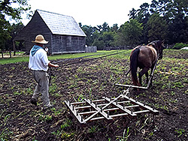
A reproduction harrow that was built using an 18th century drawing and description.

In a pre-industrial society most work was accomplished with hand tools, or those using muscle power. Agriculturally based economies therefore employed certain tools depending on the nature of crops produced. Because Virginia’s crops of tobacco and corn have Native American heritage, European settlers widely adopted Native American techniques of production, focusing on slash-and-burn land preparation, and “hoe-hill” production methods.
By far the dominant tool in Virginia during the 17th and 18th centuries was the hand hoe, in three basic forms. The narrow, or hilling hoe, possessed a long blade of about six inches width, connected to a homemade wooden shaft by a round “eye” attachment. It was predominantly used for creating the mounds upon which the plants grew and maintaining weed-free hills. Broad, or weeding hoes, were of similar construction, but up to 12 inches wide and classically used for shallow cultivation. Grubbing hoes were narrow and heavier in construction for the strenuous work of cutting and removing roots and stiff soils in land preparation.

Page 8

A reproduction hoe plow at work.
This implement was duplicated from an original artifact.

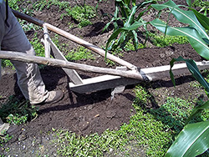

Cultivation between hills was sometimes done with light-duty, single-horse “hoe” plows. Mattocks, axes, picks and spades also helped prepare ground for initial cultivation. Harvesting knives of unknown form, along with homemade baskets for transporting tobacco seedlings and dried corn ears, essentially complete the colonial inventory for tobacco and corn production.
Native American crop technology was complemented by the more complex European technology applied to small-grain production. Bar share plows pulled by horses or oxen prepared new seed beds by turning under weeds and surface material, exposing fresh soil. This rough surface was smoothed by dragging a harrow over it to make a finer-surfaced bed for the small seeds to take root.. And it was used to cover the seeds lightly, promoting seed germination and crop establishment. Harrows were wooden frames with iron spikes or wooden teeth to break down and comb the soil surface.
Small-grain harvesting tools included crescent-shaped hand sickles with fine cutting teeth, or smooth edged reap hooks of identical form. Sickles were used like hook saws, reap hooks cut the straw with a slashing action. At least one quarter of an acre could be cut, bound and stacked by one harvester per day. Scythes were also employed in harvesting grain crops. While larger, more expensive, and requiring more strength and skill to use, they were at the same time considerably more efficient in cutting the crop. Wooden-tined cradles were attached to the long-bladed, long-handled scythe to keep the straw parallel for efficient binding.
Threshing, or separating, technology included beating the grain heads with a flail (stick tied to a stick handle), or treading with horses on a circular packed earth threshing floor. The separated material was cleaned by passing it through a riddle (course sieve) on a breezy day, or by passing it through a winnowing or Dutch fanning mill. Such manufactured devices were the only real machines applied to agriculture before more important threshing machines were perfected during the early 19th century. Half-bushel measures were often used to measure the clean grain into sacks for local milling or five bushel barrels for export.
Page 9

Does anyone know who this Vawter is?

Located on the internet. I do not know what family line he belongs to.
Send an email to Georgene or Patricia.
Office of B. P. VAWTER TOWN CLERK SCOTTVILLE, MACOUPIN COUNTY, ILLINOIS June 23, 1885
"Scottville, Illinois, May 11, 1885. Board in regular session. Election returns of May, 8th, 1885, canvassed by the Board and found regular, and they show that at said election, held in said Town of Scottville, on the 8th day of May, 1885, nineteen (19) votes were cast for organizing the said Town of Scottville under the general law of the State of Illinois, and one (1) vote was cast against so organizing said town.
B. P. Vawter, Village Clerk." State of Illinois Macoupin County Village of Scottville To Henry D. Dement, Secretary of State of Illinois. I hereby certify that the above is a true and correct copy of the original thereof now on record in my office. In witness whereof I have hereunto set my hand this 23 day of June, 1885. B. P. Vawter Village Clerk
SOURCE: Office of The Secretary of State, Index Department. Springfield, Illinois. 62756. Pages 36, 1255-1262, and copy of letter.

Altoona Iowa Church Founding and the beginning of Drake University, Des Moines, Iowa
In the beginning, before the arrival of the railroad and before there was a town called Altoona, the pioneers near what would become Altoona met for worship. I. H. Woodrow, a founder of the Altoona Christian Church, hosted the first worship service at his farm on Mud Creek in 1860.
On July 13, 1867, a group of 26 people of various denominations met to form the first formal congregation. Altoona Christian considers that date to be the founding of the church.
When the railroad arrived and built a small depot near where Burget Mill stands today, church meetings moved to town and the first Sabbath School began meeting in the railroad building.
After a decade of joint worship, the Methodists built their own building in 1870. The Christian Church held services there until 1872 when their white frame building was completed at 402 Second St. SE. The building still stands and serves as a private residence today.
During J. B. Vawter’s tenure as minister from 1875-1887, he hosted a ministerial meeting at his home. Vawter, D. R. Lucas, pastor of Central Christian Church in Des Moines and President Carpenter of Oskaloosa College proposed moving the college to Des Moines. Today that college is known as Drake University. Vawter served on the school’s first board of directors. Students studying for the ministry at Drake often filled the pulpit in Altoona in those early years.

Page 10

Dedicated to finding Vauter(s), Vawter(s), Vaughter(s)
Newsletter
June 2018 Volume 42 No 2
Reunion Dates:
Madison Indiana July 19-21, 2018
Topeka Kansas July 2019
Vauter’s Church, Virginia 2020

Website: www.vawterfamily.org
Officers
President Darren Welch, 402 N Galeston Ave, Indianapolis, IN 46229
Phone 317-899-1992 email: Darren.welch@cnoinc.com
Vice President Robert L. Vawter, 3773 Piper Bay Ln, Lakeland, TN 38002 vawter.bob@gmail.com
Treasurer Jordan M. Johnston…2450 Bear Creek Road
Pipe Creek, TX 78063 Phone…903-624-9632
email – jjohnston3200@gmail.com
Asst. Treasurer Phil Vaughter…1103 Newport, Austin, TX 78753
Phone…512-836-3105 email - PRV37@aol.com
Secretary Michelle Alexander, 489 Nannie Neal Rd, Hardin, KY 42048
Email - mrax3@juno.com
Archivist Beth Melton, 3809 Junker, Rosenberg, TX 77471
Phone 281-232-7972 email - emeltonea@aol.com
Newsletter & Georgene Jurgensen…8408 Mohican Ave
Genealogist Brooksville, FL 34613
Phone…816-591-0251 email - gfjurgensen@gmail.com
Website & Patricia Renton…2372 Bear Creek Rd, Pipe Creek, TX 78063
Newsletter Phone…830-510-4625 email - pvrenton@gmail.com

We invite everyone to update their dues or join our group. The $10 per year cost is to help offset the newsletter and other printing needs. We will send the newsletter by email unless you state otherwise. Please mail the form below and your check (made to VVVFamily Association) to Treasurer Jordan Johnston, 2450 Bear Creek Road, Pipe Creek, TX 78063

Membership form

Name:

_____________________________________________________________________________

Address: ________________________________________________________________

City:____________________________________________________________________

State:_____________________ Zip Code:_________________________________

Phone Number: __________________________________________________________

Email: __________________________________________________________________

Website: www.vawterfamily.org
Facebook: Vawter, Vauter, Vaughter Family (private group, you must request to be added)

In Memoriam
Barbara Jo Dolph, 68, of Mahomet passed away Monday morning (Feb. 12, 2018) at her daughter's home in Mansfield. Barbara Jo was born on May 29, 1949, in Effingham, in the home of her maternal grandparents. She is a daughter of Peter Harding and Nora Lee Newlin Rogers. She married Rolla Charles Dolph, Sr. on June 30, 1968, in Champaign. She later married Terry Glenn Bartley on Jan. 17, 1986, in Rockville, Ind. He passed away Feb. 28, 1997.
She is survived by her children, Rolla Charles Dolph Jr. of Urbana, Regina C. Johnson (Jason) of Farmer City and Jessica Nicole Bartley (Chris Stillabower) of Mansfield; stepdaughters, Phyllis Eldridge of Gamaliel, Ky. and Terri Glenna (Todd) Reed of Canton; stepson, Terry Glenn Bartley Jr. of Illinois; grandchildren, Joshua McElhiney, Dylan Johnson, Jacob Johnson and Logan Stillabower; step-grandchildren, John Cross, Stephanie Reed, Taylor Bartley and Brayden Bartley; brothers, Robert Alan (Lavonn) Rogers of Fisher, Gary Gene (Kathy) Rogers of Mansfield and Thomas Dean (Donna) Rogers of Salome, Ariz. Barbara Jo was preceded in death by her husband, Terry Glenn Bartley and her parents. Barbara Jo enjoyed being outdoors and loved spending time with her family. She was a loving mother, grandmother, sister and aunt who will be deeply missed.
Barbara is from the line of James Crawford and Mary (Elder) Vawter. Her line is: James Crawford Vawter, Anna (Vawter) Rogers, Edwin Peter Rogers, Peter Harding Rogers, Barbara Jo Rogers Dolph.

Joseph H. Keller, age 70, of Andrews, passed away Thursday, March 15, 2018, at 12:30 pm at Visiting Nurse & Hospice Home, Fort Wayne. He worked at Dana Corporation for 38 years and then at Huntington Sheet Metal. He was a Baptist and enjoyed hunting, fishing and coin collecting.
Joe was born November 18, 1947, in Marion, the son of Elsie R. and Alpha Ruth (Eudaly) Keller. On February 11, 1972 he married his beloved wife of 45 years Carole S. Prater in Lagro and she survives in Andrews. Also surviving are 2 daughters Valerie (William) Nichols of Andrews and Vickie (Brian) Baker of Huntington, 5 grandchildren Chelsi Johnson of Huntington, Jade Johnson of Andrews, Samantha (Jay) Monroe of Huntington, Sarah Murdock of Marion, and Jessie (Joe) Robbins of Huntington, 6 great-grandchildren, a brother Bill (Leann) Keller of Marion and a sister Alice (Benny) Collins of Fairmount. He was preceded in death by a daughter Tena Johnson, a great-grandson EJ Robbins, 3 sisters and 2 brothers.
He is a descendant of the Vawter family. He is the Grandson of Louella (Vawter) Eudaly.

Jack D. Vawter, 86, passed away on February 7, 2018. He was born on March 31, 1931. Jack was a veteran serving in the U.S. Army. He was preceded in death by his parents Paul D. Vawter and Charity Smith, first wife Peggy Ann Vawter and sisters Ann and Debby. Surviving family includes wife, Mary Ann; children, Jack D. (Janet) Vawter Jr., James (Jeff) Vawter, Charity (Gerald) Smith, Lora Vawter, Cathy (Mike)Rogers, Jeanette (Greg) Wyatt; grandchildren, Chantelle (Nathan) Dawson, Brittney (Tim) Morales, David (Alivia) Vawter, Savannah Vawter, Jared Smith, Jennifer (Ken) Dixon, Megan (Russ) Hone, Scott (Liz) Rogers, Samantha Wyatt, Greg Wyatt, Andi Wyatt, Shane Wyatt; many great-grandchildren; brothers, Bill (Delores) Vawter, James (Arlene) Vawter, Paul (Kathy) Vawter; sisters, Barb (Bud) Ysseldyke and Paula Pierce.

Page 2
Mrs. Elizabeth Keith Vaughter, age 90, of Nashville, went to be with her heavenly father Monday, April 23, 2018. She was born December 3, 1927, in Chattanooga, Tennessee, to the late Hazel (Bryan) and Varner Keith. She was preceded in death by her husband of 49 years, William Eugene Vaughter.
Her childhood was spent in Graysville, Tennessee, where she attended Rhea County High School, then graduated from Middle Tennessee University. At 19, she interviewed troops and POWs returning from war, and later worked for both the TVA and The Corps of Engineers. While taking care of and providing for her family was her life’s mission, she was especially proud of her years in the classroom, teaching in one of the nation’s first Head Start programs and, later, in elementary school education. Her devotion to teaching most certainly enriched many lives. She enjoyed travel, reading, politics, history and genealogy, but time with her family was paramount to all other pursuits.
Mrs. Vaughter is survived by her son, William Vaughter (Virginia); daughter, Beth Vaughter Smith; and granddaughter Rebecca Smith.
Beverly J. Johnson passed away Wednesday, December 6, 2017 at home. She was born August 2, 1934 in Topeka, Kansas, the daughter of George and Virginia (Vawter) Reaser. She married James H. Young on November 23, 1952. He preceded her in death on April 30, 1987. She married Merlin R. Johnson November 18, 1989. He survives. Other survivors include a daughter, Kyla J. Glaser-Young of San Diego, California; three stepchildren, Kenneth B. Johnson (Susan), Overbrook; Randall E. Johnson (Gail), Baldwin City; Brenda Jo Wettengel (Bill), Perry; nine grandchildren, 26 great-grandchildren, two great-great grandchildren and several nieces and nephews. She was preceded in death by her parents and a sister, Sharon McCrory.
Beverly was a Program Assistant for the USDOL, Veterans’ Employment and Training Service for 35 years, retiring June 5, 1997. She was also an agent with Greenbrier Real Estate of Topeka. After retirement she and Merlin moved to Beaver Lake, Arkansas. In 2005, they returned to Pomona Lake, Vassar, Kansas and then to Brewster Place, Topeka.
She is a member of the Methodist Church, Vassar. She has been a member of Daughters of the Nile, the Shawnee Boat & Ski Club, Swinging Squares dance club, the Red Hat Society. She was an avid Jayhawk basketball fan! Beverly was the daughter of Virginia Vawter Reaser. Virginia’s parents were Clarence Vawter, Sr. and Leola Bixby Vawter, Clarence Sr. was the son of J.D. Vawter
Celebration of Life

Everett Gray Vaughters was born on March 21, 2018 in Mourt Pleasant, SC. Parents are Brian and Kayla Vaughters of Hanahan, SC. Everett and his brother Brannen Craig Vaughters are the grandsons of Jon Craig Vaughters and Mary Dee Vaughters of Surprise, Arizona. Thanks to the genealogy research of Great-Grandfather E. B. Vaughters, we can trace our lineage back to Bartholomew Vawter.

Page 3

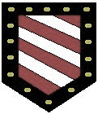
VVV Family Reunion, Indiana
July 19, 20, 21

Please print or save these pages and bring along with you to the reunion. It will help to let you know the schedule of events.

2018 REUNION PLANS

The time is almost here for the 2018 reunion of the VVV Family Association. Reservations have been
made, and on the list are many familiar names as well as some who have never attended a reunion.
Sadly, a few regular attendees are not able to be with us this year.

Thursday, July 19. Registration begins at 3 p.m., Thursday, July 19, in The Overlook room
at Clifty Inn. This is also the room where we will have our meetings, displays and buffet dinners.

Friday, July 20. The opening meeting at 9 a.m. on Friday starts with the ringing of the cowbell
by the youngest child in attendance. Following the meeting, everyone is encouraged to participate in a genealogy session led by Georgene Jurgensen.

At past reunions, we have learned that some people prefer free time to explore on their own, while others would rather have something more structured. This year we have decided to have both. Following the Friday morning meeting and genealogy session, you can browse the shops in downtown Madison, visit the Jefferson County Public Library, relax along the Ohio River, hike or swim at the park, or just stay at the inn and visit with other family members and look at the items on display. Our evening meal will be a buffet dinner served in The Overlook room.

Saturday, July 20. Saturday, we travel 20 miles north to Jennings County. We will spend time at the Vernon Cemetery and the Jennings County Historical Society in Vernon. After having lunch at the historical society, a visit will be made to Selmier State Forest, located about six miles from Vernon. This area was once the home of William and Frances Vawter and is the location of the Vawter-Summerfield Cemetery. On the return trip to Madison, we plan to stop at the Wirt Baptist Cemetery, where Jesse and Elizabeth Watts Vawter are buried. Some of you may remember these cemeteries from previous reunions. The reunion ends with a buffet dinner that evening, followed by our traditional closing meeting that includes a memorial service.

Page 4

REGISTRATION AND MEALS

The registration fee for the 2018 reunion has been set at $10.00 for each adult.
This fee helps pay for expenses associated with the event. There is no fee for those
under the age of 18.
On Friday and Saturday nights, we will have a buffet dinner served in The Overlook room.
The cost of this is $21.00 each night for children over the age of eleven and adults.
Meals for children ages 4 – 10 are half price.
Saturday lunch will be provided by the Jennings County Historical Society in Vernon.
We are asking for a $5.00 per person donation to help with their costs.

VAWTER HISTORY ITEMS TO DISPLAY AND SHARE

Do you have Vawter, Vauter, Vaughter(s) memorabilia? We will have tables available
in The Overlook room for you to display and share those items. Perhaps you have
old family photos, binders of information, reunion photos, family charts or something
showing the family name.
On display from the association archives will be the street sign from England and the
hand painted sign from Vauter’s Church. The room with be secure to leave your items over night.

SATURDAY NIGHT DOOR PRIZES AND AUCTION

The VVV Family Association has established many traditions over the years.
One of those is having door prizes at the Saturday night meeting. You are invited to
contribute an item brought from your area, something you have made, or perhaps
an item that catches your eye while shopping in Madison. A more recent tradition
is the auction. Some people bring items specifically to be auctioned, or at times we
choose door prizes to auction. Proceeds from this go to Vauter’s Church in Virginia. We do
want to emphasize that it is not mandatory to contribute auction or door prize items.

ARE YOU NOT STAYING AT THE CLIFTY INN?

We are aware that some people may not be staying at the Clifty Inn. You may have
reservations at a different hotel, or live in the area and plan to commute from home.
If either of these is the case, it would be helpful for us to know so we can have a better
idea of how many to expect.

Please email your information to Bonita Welch at bwelchbf@yahoo.com.

Page 5

Jefferson County, Indiana Local History

Vawter Family history

Written by John Vawter on April 13, 1850, and published in the Madison Courier on April 4, 1874
Father with six or eight others, Kentuckians, from Franklin and Scott counties, visited what was then called the new purchase at a very early date. A part journeyed by land and a part by water. The land party crossed the Ohio river at Port William, the others descended the Kentucky and Ohio rivers in a pirogue to a point opposite Milton. The pirogue answered the double purpose of carrying forward the provisions for the company, and enabling the men to pass from one side of the river to the other, and swimming their horses by the side thereof, from one side of the river to the other. The company made their headquarters in the river bottom in the eastern extremity of the city limits of Madison. In the day the company divided into two parties, explored the adjacent highlands to the head of Crooked Creek and the neighboring lands of Clifty. They met at night and reported their discoveries to each other. To Crooked creek they gave the name of Mill creek, to Clifty, Hard Scrabble, but subsequently on learning the name of each stream, the Red man’s name prevailed with the settlers. At that time, December 1805, Elder Jesse Vawter selected for his residence the spot where Judge S. C. Stevens now resides on the hill. He returned home and made every arrangement for taking possession of his new home early in the spring of 1806. He with others made the first settlement in and about Madison.
Nearly all the settlements made in that year, and the two or three succeeding years were made on the highland. Among the first settlers in the county were Elder Jesse Vawter, Jas. Underwood, Joshua Jackson, Colby Underwood and Jas. Edwards, all of the Baptist denomination as professors of religion. East of Crooked creek Col. John Ryker, Paul Froman, Ralph Griffin, Joseph Lane and others, the two last and (their) families were Baptist. West and Southwest Col. Samuel Smock, James Arbuckle, Michael and Felix Monroe, Isaiah Blankinship, Amos Chitwood and others.
The first corn and other kindred productions raised in Jefferson county was in the year 1806, most of which was planted as late as June. The first preaching in the early settlements within the bounds of Jefferson and Switzerland counties was by Baptist ministers. Elder Jesse Vawter, John Taylor, Philemon Vawter and John Reese were early settlers and the only resident ministers at an early day in the vicinity of what is now the city of Madison. From the year 1805, their first visit,
Page 6
until 1810 there was not an organized church in the limits of what is now Jefferson and Switzerland counties except Baptists. The first organized religious body within said counties was Baptist. In March 1807, on the spot where the Hon. S. C. Stevens once resided, a Baptist church was organized called Crooked Creek Church, afterward Mount Pleasant, now Madison.
The first settlement made in the river bottom near Madison was made by William and John Hall in 1806 or ‘7 a little above Isom Ross tanyard (purchased out by Johnathan Lyon in 1808). The second was made by John H. Wagoner on the high bank a little west of Main street, in Madison. Wagoner unloaded his boat on the 10th day of May, 1808, and immediately commenced building him a tenement to live in. The third person who settled in the limits of the present city was Robert M. Trotter, afterwards a Justice of the Peace; the fourth was Joshua Wilkinson, a single man; the fifth was Joseph Strickland, afterwards Justice of the Peace, and with Strickland came a man by the name of Schofield (and perhaps others not recollected). Next came John Booth, the first inn-keeper; then John Sering, Samuel Burnet (second innkeeper); Charles Easton, with a number of others, which brings us down to the time of the first sale of lots in Madison in February, 1811. During all the above time, all the preaching for twenty to thirty-five miles up and down the river and through the county was of the Baptist order.
The first sermon ever delivered within the chartered limits of Madison was by Elder Jesse Vawter, amongst the cottonwoods on the river beach, a little above the stone mill. The text was the first verse, first chapter of John’s Gospel. It was a funeral occasion, the death of the widow Slack. Mrs. Jonathan Lyon, mother of Philemon Vawter, closed the service. This was the first death and funeral preached within the vicinity of Madison. After the land sales in May 1808, and the sale of lots in Madison in 1811, the town and country commenced filling up pretty rapidly with settlers. The first man who preached in Madison other than Baptists was of the name of Hawkins, a Hell Reductioner, who afterwards became a convert to Baptist sentiment. Sometime after the establishment of Courts in Madison, and during the sitting of the Court, Elijah Sparkes, an attorney-at-law and Methodist preacher, and Jesse L. Holman, a Baptist exhorter, both of Dearborn county, during Court week preached for the people at the house of Philemon Vawter, near the Crooked creek grave yard. This was the first Methodist preaching in the immediate vicinity of Madison.
After public buildings (Court House) were erected in Madison, Col. Brown, a Methodist preacher, preached in Madison, another by the name of Frame, and so did old Dr. Fisk. About this time, if I mistake not, Dr. Oglesby commenced preaching in Madison, also a man by the name of Strange, also Squire Strother (of Kentucky) and Amos Chitwood.
Page 7
In the year of 1812 or 13, not earlier, a Methodist meeting house was built in Madison, and from that time Methodism began to take root and grow in the country.
About this time Elder Wm. Robinson, a Presbyterian preacher, moved into Madison and commenced preaching, and soon organized a church of his order. He was succeeded by a man by the name of Searl; and Johnson succeeded Searl. So much for the early religious denominations about and in Madison.
The writer (John Vawter) was the first Justice of the Peace within the vicinity of Madison while it was in Clark county. His commission bears date the 16th of July 1808. The first Judges for Jefferson county were Gen. Wm. McFarland, President, and Samuel Smock and Wm. Colton, his associates of the Court of Common Pleas. The first Clerk and Recorder was Col. John Paul, second clerk, Richard C. Talbot, First Sheriff John Vawter, commissioned such the 14th of December, 1810, retired from the office by virtue of a commission dated 29th of July 1813, as U. S. Marshal for the Indiana Territory, Second Sheriff, James Vawter (I am not certain but what Basil Bently was the second Sheriff in Jefferson county, but very soon retired from office), the third Sheriff, Thos. T. Stribling.
The first Court ever holden in Jefferson county was holden in a log cabin owned by John H. Wagoner in February, 1811. The sale of the first lots in Madison (old town) was in the same month; the first proprietors, Col. John Paul, Lewis Davis and Jonathan Lyon; the first addition west, surveyed by the writer for Col John Paul. The first Court House, called the Buckeye House, was built in 1811. It was built by the writer for proprietors. The first jail was a square log house, builder’s name not now recollected; first public house was kept by John Booth; second, by Samuel Burnet; third by Major Henry Ristine.
The first store was owned by John Sering & Co.; a drug store was started about the same time by Dr. Drake & Co.; the third store was opened by S. C. Stevens; fourth by the writer; fifth by J. & N. Hunt; sixth by McCabe & Co.; seventh by Mr. Clarkston; eighth by John McIntire. The first physician was of the name of Fisk; second, James Hicks; third Jno. Howes; fourth, David H. Maxwell. The first Attorneys General, Alex. A. Meek; the second, a man by the name of Oulds; third, Gen. William Hendricks. The first dray ever used in Madison was owned by Simeon Reynolds, and managed by his most excellent son, William L. Reynolds.
Page 8
The writer was personally acquainted with the first proprietors of the town. A more excellent or upright, good man than Col. Paul was hard to be found. He was one of Gen. George Rogers Clark’s bold, adventurous soldiers, who aided in the capture of Kaskaskia and Vincennes. He was elected one of the representatives from Clark county in the year 1810. This was previous to the formation of Jefferson county and Col. Paul then resided at Madison. He was also one of the members of Jefferson co. who formed the present constitution of Indiana. The writer was crier of the first sale of lots in Madison, but had nothing to do with the surveying or laying out of the same. Laid out the first addition west of Broadway for Col Paul in the winter 1814 and 1815. Had nothing to do with any additions to the town.
My second visit to Indiana was in May 1806. I came in a pirogue and landed a little above the stone mill opposite Milton, visited the Highlands east and west of Crooked creek, continued at my father’s half-faced shanty until near the middle of June in order to assist him in getting his corn planted, returned in the same craft with my mother and other relatives to Frankfort, Ky. In September 1806 my father removed his family from Kentucky to Mount Glad, the place where Judge S. C. Stevens now resides. In December 1806 I made my third visit to Indiana in company with John Branham, a brother-in-law, and James Vawter, we aided in driving my father’s cattle and fattened and stock hogs from his Kentucky residence to his new home in the then wilderness.

At this time I made a selection of a place to move myself and family to in the coming spring. It is the identical spot where the depot and machine shops of the railroad company are now upon the hill. In March 1807 I arrived with my family, wife and one child, at my original selected site in the woods. In 1808 I built a house nearly opposite Godman’s pork house on the hill and resided there until 1812. In this year I purchased property in Madison and moved to it. The property purchased by me was two lots on Main Cross st. east of Polley’s and Butler’s Iron store and west of Mulberry st. In 1814 I sold both lots to Mr. David McClure.

In the winter of 1815 I purchased of Col John Paul the corner now owned by Geo. M. Phelps, and built a large frame house (large for the size of the houses in Madison). Had the water conveyed by pipes, in connection with Col. Paul, from the hill at Hite’s tan yard to the same, expecting to live and end my days there. In the same year I sold it also to David McClure, moved to Vernon in November 1815 and continued to reside there until November 1849 with my family and children. Since November 1849 have resided in Morgantown, Morgan Co., Ind.

A LOCAL HISTORY PROJECT BY THE JEFFERSON COUNTY PUBLIC LIBRARY

Page 9
Charles Publius Vawter
b. ca 1851 KY (parents unknown)
m. ca 1775 to Susan Degman b.ca 1856 KY
Children:
Lula Vawter b ca. 1876 KY
Charles Richard LeRoy Vawter b.22 Sept 1878 KY
James A. Vawter b. ca 1879 KY

In 1880 Charles P. Vawter was living in Orangeburg Twp. Mason Co., KY and in 1900 living in Dist 99, Mason, KY
The 1900 census states 6 children were born between 1875 and 1900 and only 2 were still living. Son Charles R L Vawter was single age 21 and living as a boarder in school. Other child unknown.

The 1920 census of Plumville, Mason Co., KY shows Charles P. Vawter age 69 servant and a widow in the household of Mary A. Degman age 71 and her sister Ida C. McDonald age 52 and her dau Nancey Doruella age 25.

The Dunlavy Funeral Home, Enid, OK index Aug 1923-Mar 1946
Puilus Vawter age 81

Charles Publius Vawter’s parents likely are the following:
1850 Jefferson, IN census:
Paschal Vawter 37 Farmer b. IN
Elizabeth Vawter 37 b. KY
Mary A Vawter 13 b. IN
John B Vawter 11 "
Samantha Vawter 9 "
Aurelin Vawter 7 "
Ailsey Vawter 5 "
Doshum Vawter 3 "
Publius Vawter 1 "

Charles Richard LeRoy Vawter b. Sept 1878, Mason, KY
He was living in 1900 in Fayette Co., KY as a boarder at school. Marriage record of Sonora, Hardin, KY shows Charles Richard Vawter marriage to Carolyn Della Morrison on 20 May 1903.
However, in Sept 1904 on the passenger ship, Excelsior, arriving in New Orleans he states he is single, living in Cuba, and age 26. He was traveling to the St. Louis Exposition. GJNote: Had he and wife left for Cuba and he returned alone? Did the wife and children die in Cuba before 1910?

The 1910 census shows him back in his parent’s home in Hamilton Co., OH. It shows him as a widow with 3 children, 2 children deceased. Only one child was still living, a daughter Velma who was born about 1905.
In 1912, a ship registry shows him arriving from Southampton, England on 20 Oct 1912 in New York.

In 1918, Charles R. L. Vawter address 2418 Myrtle, Kansas City, Jackson Co., MO filed his registration card for WWI. He stated he was 40 b. 22 Sept 1878 and was a clergyman. He listed nearest relative as Della M. Vawter at the same address.
In the 1920 census Jackson Co., MO he lists himself age 40 and wife Caroline age 39. Also listed is daughter Velma at 15 and 3 additional children, Beverly age 8 (son), Errett or Evrett age 5 (son) and Jack Morrison Vawter age 11 months.

Page 10

JACK MORRISON VAWTER, 93 of Louisville, died Friday, April 27, 2012 at his residence. He was a retired director of systems for the Old Louisville and Nashville and CSX Railroads where he worked for 45 years. Jack was a flight instructor for Kentucky Flying Service, an Army veteran of World War II where he was a tank commander in the Battle of the Bulge, a member of Midland Trail Golf Club where he had two holes in one, a member of the University of Louisville Honor Society and University Club and Holy Trinity Catholic Church. He is survived by his wife of 70 years, Peggy Abell Vawter; nieces, Jackie Coble, Beverly Mattingly and Dr. Margaret Rose Stone; and a nephew, Kendall Stone.

1930 Census then shows Carolyn Vawter in San Antonio, TX. Carolyn age 44 b. KY and sons Errett age 15 and Jack age 11 b. MO were living with Hilary Cleaver age 33 KY and wife VELMA Cleaver age 25 b KY. Velma was likely the child of Charles R. L. and Carolyn Della Morrison Vawter. Also in the household is Hilary and Velma’s children Marjorie Cleaver age 9 and Hilary Cleaver Jr. age 8 mo both born KY
(GJNote: problem, Carolyn states she is a widow but likely she did not state she was divorced) Charles Richard LeRoy Vawter and Caroline Della Morrison Vawter were likely divorced bet. 1920 and 1923.

Carolyn Vawter d. 27 Aug 1937 Louisville, Jefferson, KY age 48. Father listed as Elan A. Morrison and Rachel Nelats?
Charles Richard LeRoy Vawter married to Clarkie Reaves on 26 June 1924 in Franklin Co., OH. He lists his parents as C. P. Vawter and Susan Degman and was age 45 b. 22 Sept 1878. His wife Clarkie lists age 27 b. 3 Aug 1923 b. in Ripley, TN Her father is listed as T. D Reaves and Nellie Clark, mother. He states his address in Enid, OK.

Charles lists a previous wife deceased and she states she was not previously married. They lists their occupations as Clergyman and Evangelistic singer. Married by Rev. Arther Vawter, relationship unknown. (GJNote: could this be James A. Vawter, his brother)

In 1924, several newspaper articles from Mexia, TX show Charles R. L. Vawter Evangelistic clergy and Miss Clarkie Reaves singer along with Will D. Reaves and Mr. Howard T. House were performing and preaching throughout the area. She was using her maiden name. The articles tell that during his 19 years of evangelical work he had traveled to Canada, Australia and New Zealand. He is listed as having a popular following and national reputation.
Charles and Clarkie are shown on a ships registry returning from Bremen, Germany 18 Aug 1926. In 1930, Charles and Clarkie are shown on a ships registry returning from Cherbourg, France 9 Sep 1930 New York.
No children were found from this marriage.

Charles R. L. Vawter born 9. 22. 1880 d. 1.04.1935 son of Pubilus and Susan Degman Vawter Cemetery records of Memorial Park Cemetery, Garfield County, OK (GJNote: birth year is 1878 as stated by Charles in several records)

In 1940 the Census of Enid, OK shows Clarkie Vawter female, the city directory shows her as Vawter, Clarkie R. (wid of Chas R)

Page 11

Trematon Castle is located in Cornwall England.
The keep still stands today, along with part of the wall system. It has been long thought the name of Vawter came from the name Valletort. Reginald Valletort was a knight who was granted these lands. No proof has been found but the name of Vawter is only found in this area of England. Saltash, a small community, has many Vawter families yet today. The castle is currently open to the public. Thursday, Friday and Saturday 11.00am - 4.30pm.
The keep is oval and has walls 10 feet thick and 30 feet high.^{[1]} The internal diameter is approximately 21 metres. A rectangular gatehouse, built in 1270, has two floors and a portcullis. Both are in good condition.

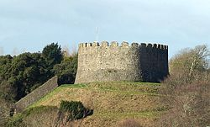

The castle was established here by Robert, Count of Mortain soon after the Norman Conquest.^{[2]}
From the Conquest until 1270, the rights for the ferry from Saltash Passage on the Plymouth side of the River Tamar to Saltash belonged to the Valletort family. When Roger de Valletort sold Trematon Castle and manor to Richard Earl of Cornwall, the rent was paid to the Earl's bailiff. In the thirteenth century, this amounted to nearly seven pounds sterling.
The Castle has remained the property of the Earls and Dukes of Cornwall without interruption since 1270, when Earl Richard bought it for £300.^{[1]}
When Sir Francis Drake returned from his circumnavigation voyage in 1580, he came into harbour in Plymouth, then slipped out to anchor behind St Nicholas Island until word came from Queen Elizabeth's Court for the treasures he had gathered to be stored in Trematon Castle.^{[3]} The hoard consisted of gold, silver, and precious stones, mainly emeralds, the result of piracy from Spanish ships along the west coast of South America. Before being moved for storage in the Tower of London, the treasure was temporarily stored in the Golden Hinde.
In 1961 the Duchy of Cornwall advertised the Castle to be let on a full repairing lease for 21 years, with breaks, at a rent of £250 a year.^{[1]} It subsequently became the home in Cornwall of Hugh Foot, Lord Caradon, and his son Paul Foot, a campaigning journalist, spent some of his youth there.^{[4]}
Queen Elizabeth II visited the Castle on 25 July 1962 accompanied by the Lord Lieutenant of Cornwall, Sir Edward Bolitho, before driving to Fowey and embarking in the royal yacht Britannia.^{[5]}

Page 12

Dedicated to finding Vauter(s), Vawter(s), Vaughter(s)
Newsletter
September 2018 Volume 42 No 3
Reunion Dates:
Topeka Kansas July 2019
Vauter’s Church, Virginia 2020
Memphis, TN 2021

Website: www.vawterfamily.org
Officers
President Robert L. Vawter, 3773 Piper Bay Ln, Lakeland, TN 38002
Email - vawter.bob@gmail.com Phone 901-438-4563
Vice President Michael McNary, 6500 86th, Meriden, KS 66512
Email – mmcnary@farmersagent.com
Treasurer Jordan M. Johnston…2450 Bear Creek Road
Pipe Creek, TX 78063 Phone 623-242-9296 Email - jjohnston3200@gmail.com
Asst. Treasurer Phil Vaughter…1103 Newport, Austin, TX 78753
Phone…512-836-3105 Email - PRV37@aol.com
Secretary Michelle Alexander, 489 Nannie Neal Rd, Hardin, KY 42048 Email - mrax3@juno.com
Archivist Bonita Welch, 4145 Co Rd 900w, Scipio, IN 47273
Phone -812-392-2149
Email – bwelchbf@yahoo.com
Newsletter & Georgene Jurgensen…8408 Mohican Ave
Genealogist Brooksville, FL 34613
Phone…816-591-0251 Email - gfjurgensen@gmail.com
Website & Patricia Renton…2372 Bear Creek Rd, Pipe Creek,
TX 78063
Newsletter Phone…830-510-4625 Email - pvrenton@gmail.com

We invite everyone to update their dues or join our group. The $10 per year cost is to help offset the newsletter and other printing needs. We will send the newsletter by email unless you state otherwise. Please mail the form below and your check (made to VVV Family Association) to Treasurer Jordan Johnston, 2450 Bear Creek Road, Pipe Creek, TX 78063

It’s never too early to start planning your vacation for 2019.

Topeka, Kansas will be the location July 18 to 20.
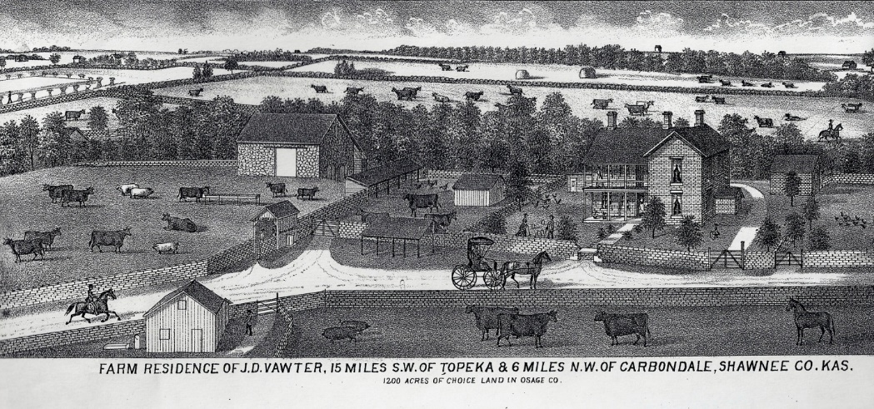
Hosted by the McNary
family . We will be
touring some historic
family sites of J. D.
Vawter and some
Kansas historical
connections. Lots of information about the
hotel will be in the
December newsletter.

In Memoriam

New Bern, NC. Oberia "Bee" Frances Carroll Vawter, 88, died July 26, 2018. She was born June 23, 1930, in Reidsville, NC to Frank and Mabel Carroll. On March 31, 1950, Bee married Walter "Ray" Vawter, Jr. Without a doubt, Bee would say her greatest joy in life was her family. She worked a variety of jobs, but by far her most favorite occupation was that of switchboard operator.
Relationships built through the Church and alliances with fellow Civitans brought tremendous joy and companionship.
Bee is survived by her husband, Ray; daughter Judith Alexander (Win) of Greensboro and her children, Scott Kelly (Kathy), Kathryn McMillan (Patrick), Ashley Garcia (Rolando), Derek Kelly and girlfriend Katie Glester; daughter Cindy Sutherland (Terry) of Greensboro and their children, Wayne Sutherland (Kyndal), Candace Matthews (Derrick); and daughter Pam Price (Joe) of New Bern and their daughter Olivia Gill (Timothy). Great grandchildren include Kandis Grist, Nicholas Kelly, Colt Matthews, Connor Kelly, Graham Sutherland, Tyler Matthews, Tucker Sutherland, Daniel Garcia, Lachlan McMillan, Ella Garcia and Oberia "Obie" McMillan. Bee is also survived by her loving and devoted brother, Phillip Carroll and his partner, Gary Thrailkill of Concord and three nieces, Faith Billingsley and Brenda Williams of Reidsville, and Suzanne Carroll of Martinsville.

Farmington, IL - Harry Richard Vawter, 82, of Farmington passed away at 6:31 p.m. on Tuesday, June 5, 2018, at Unity Point Health Methodist.
He was born on September 29, 1935, in Bevier, MO, to Harry Lee and Edith (Gilstrap) Vawter. He married Patricia Wasson on June 14, 1959, at the First Baptist Church in Farmington. She survives. Also surviving are three children, Allison Vawter Ossman, Lisa Vawter Sheffield and Scott (Beth) Vawter; six grandchildren, Rachael (Jason) Rockhold, Joel (Sarah) Ossman, Nick (Madi) Vawter, Hannah Ossman, Jon (Brittany) Vawter and Drew Vawter; seven great-grandchildren; one sister, Connie (Paul) Bugos; and sister-in-law, Alice Vawter.
Harry was preceded in death by his parents and one brother, Donald Vawter.
Harry retired as an electrician from Caterpillar after 38 years of service. He was a member of First Baptist Church in Farmington. Harry loved spending time with his family, especially his grandchildren.

Harry served in the United States Army.

Woodville, WY – Russell W. Vawter, 79, of Woodville, passed away Tuesday July 31, 2018, at his residence. He was born July 11, 1939, in Wyoming, MI, the son of Carl and Harriet (Austin) Vawter. After high school, Russell served in the U.S. Air Force for four years. Following his discharge, he returned to the Grand Rapids area, and worked as a driver for Greyhound Bus Co. for 25 years.
On August 26, 1978, Russell married Virginia Rose (nee Warner). In 1984, the couple built the Woodville Country Store, which they operated for a number of years. Russell was active with other projects in his “retirement” years, and was also an avid hunter and fisherman.

Surviving are his wife Virginia “Jenny”; his children Nick (Noemi) of Woodville, Karen DeJonge of Florida, Wayne (Madeline Shefke) of Fremont, Roy (Anne) of Byron Center, Larry (Gemma) of Sparta; his step-children Del Robinson, Jerri (Tom) McCarthy, and Pauline (Mike) Fuller; and many grandchildren and great-grandchildren. He was preceded in death by a step-daughter Sue Ann Humphrey.

Macomb, IL - Michael Thomas Vawter was born on November 3, 1952 at St. Francis Hospital in Macomb, Illinois. He departed this life on Monday, July 9, 2018 peacefully in his home.

Mike graduated from Macomb Senior High in 1970 and from Western Illinois University in 1990 with a degree in Supply Chain Management. Mike married Charlotte Pointer and to this marriage one child was born, Chanda Dee Vawter. Chanda was his pride and joy. One of his proudest moments was attending Chanda's pinning ceremony upon the completion of her nursing degree.

During his lifetime Mike had several jobs. He worked for General Telephone Electronics for several years. Later, he worked for ZATA Industries, Kroger, Webster, and Maytag in supply chain management.Michael took great pleasure in spending time with his family and friends, especially his daughter and her fiancé Roger Tobiasz.

Mike is survived by his brothers Marc, and David (Alison); his sister Sue Kupfer (Bob); his daughter Chanda; his brother-in-law Jim Bennett; his ex-wife Charlotte; and his step-sisters Kathy Torrance, Pam Knudson, and Angie Klemp. Also surviving are his nephews Jason (Misha) and Scott (Jennifer)Bennett and Clay Kupfer (Melissa) and Geoffrey Bennett ; nieces Maggie and Frances Long; and great nieces Carley, Annie, and Emily Kupfer and Sydney Bennett.

Mike was preceeded in death by his father Max Vawter; his mother Ruth Kugler; his step-father Bob Kugler; and his sister Janis Bennett.

Saskatoon, Canada - Perle Lloyd Vawter July 20, 1928 – July 10, 2018

It is with profound sadness that we said goodbye to Lloyd at the University Hospital at the age of 89. He will be dearly missed by his wife of 65 years, Joan; His Son Kelvin of Richmond B.C. and Daughter Sheila (Kim) Peterson of Midale SK. His Grandchildren; Jake (Hua), Tommy, Jordan (Care), Kataka, Tashaun, Demarco, Jason (Monica), Erica (Conrad), Kelsey (Jesse), and Courtney; and twelve great grandchildren. Siblings; Dorothy, Lillian, Freda and Grant (Diane) and numerous nieces and nephews.
Lloyd was predeceased by his parents Lloyd and Jenny; two children Sheralynne, and Mark. His brothers Kelly, Virgil, Earl, his sisters Julia, Muriel, and Ruth.
Lloyd was first and foremost a man of faith. He had been involved and active in his church community for his entire adult life.

He was totally devoted to his wife of 65 years, Joan, and never ceased to love and care for her. He took great pride and joy in his children, grandchildren and great-grandchildren and loved to spend as much time with them as possible. The feeling was mutual! Lloyd was an enthusiastic member of an entertainment group several years ago and he and Joan spent countless hours singing, playing instruments, telling stories and reading poetry at Senior’s residences in Saskatoon. Lloyd also spent several years with the Saskatoon Choral Society, and was a dedicated member of the church choir for many years. He was an avid sports fan and during his life played hockey, baseball, curling and golf.

Columbus, OH - Beverley (Vawter) Baker a true fighter to the end, 80 years young of Columbus, Ohio, passed peacefully in her sleep on August 20, 2018, surrounded by her loving children, sister Barb and granddaughters.
Preceded in death by her parents, John and Ruth Vawter; daughter, Jody Lynn Baker and her beloved dog, Gabby. Mother to Brad Baker (Christi), and Terri Baker; sister to Barbara Forest (Frank), Thelma Breech (Ron); grandmother to Amber VanMeter (Monty), Lauren Baker, Austin Sohr, Alexander Hebert, Kristin Baker and Lindsey Hebert; great-grandmother to Devon Maurice Jones; aunt to many fantastic nieces and nephews. Graduate of Central High School, 1956. Retired from Broward Community Foundation in 2000.

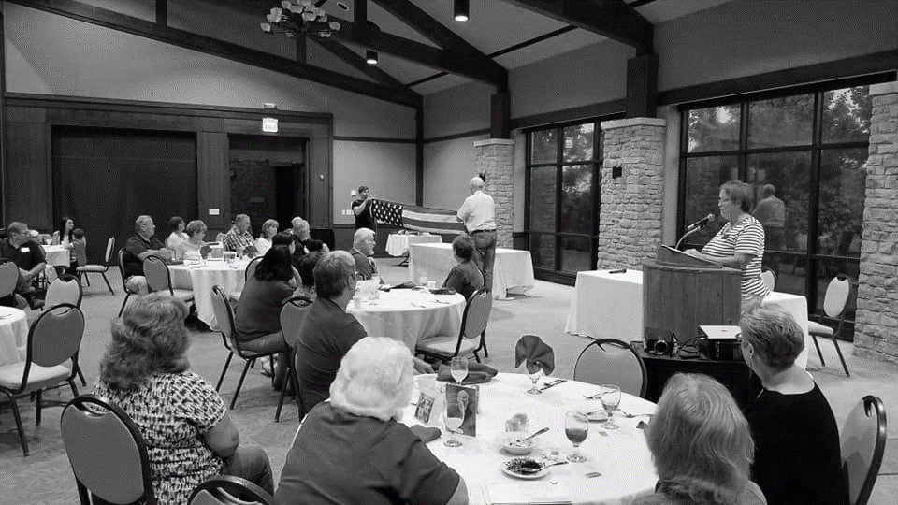
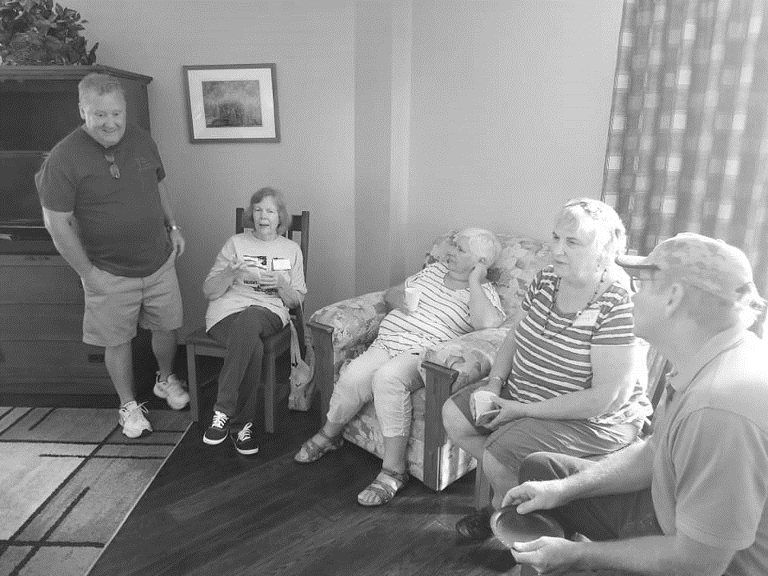
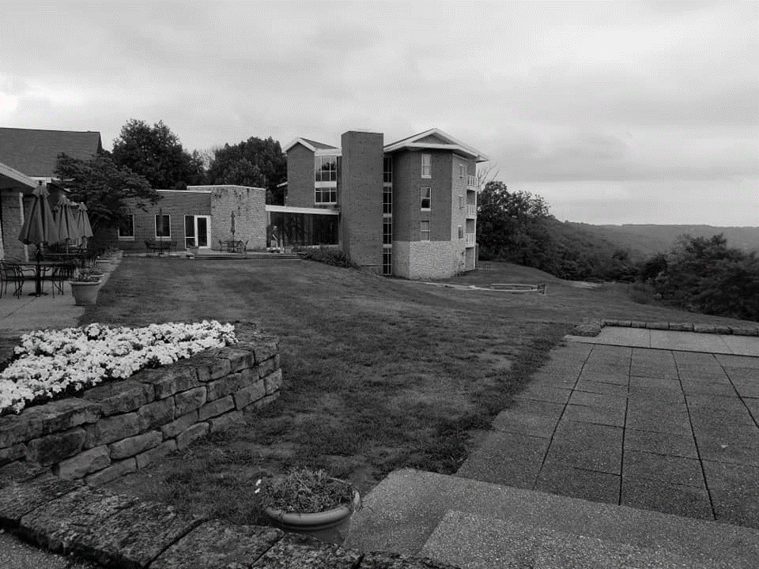
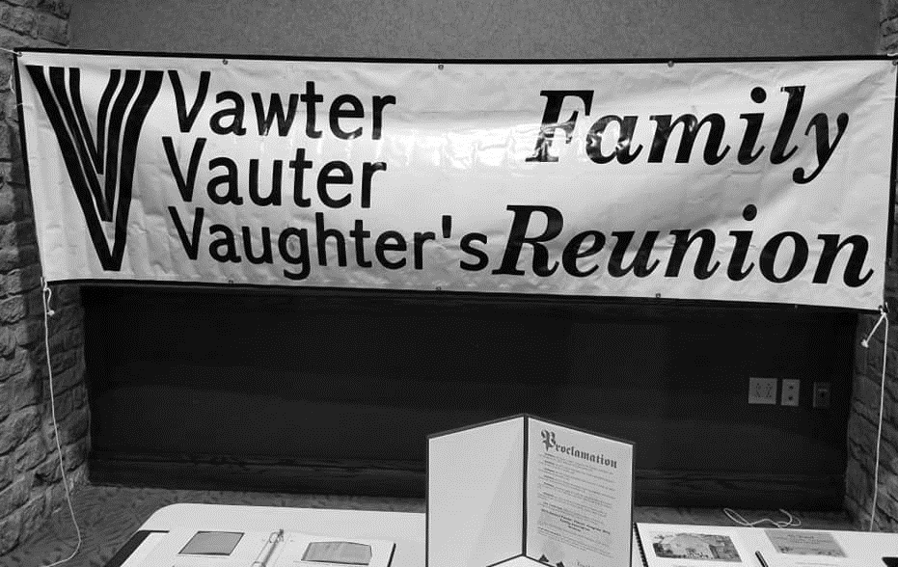
Friday night was a great presentation of the folding of the American Flag and a power point presentation of the Robinson family connection
The 2018 Reunion was in Madison IN at the Clifty Falls State Park. A great place with lots of history. The Welch family put on a great reunion with tons of historical documents and a great program. A tour of the local area including the town of Vernon was held on Saturday.
Thursday night, meet and greet. Making new friends and greeting old ones. It was a fun filled 3 days.
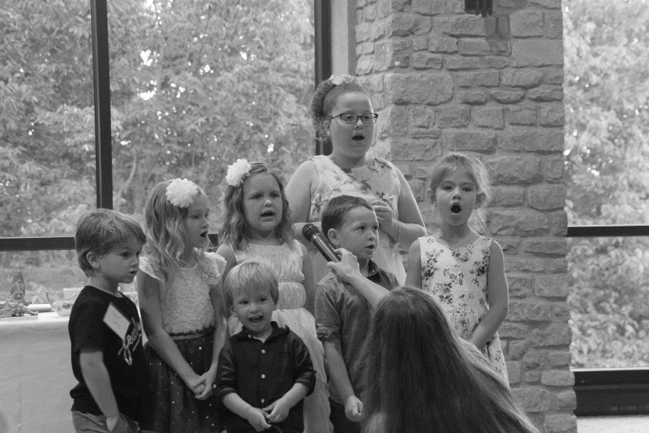
Just some of the events during our July reunion. Darren Welch, president, kicks off the event and welcomes the group. The children presented a great song fest on the Saturday night banquet. Our memorial service presented by Ellen Cummings with the some great helpers, where we honor those who have passed during the previous year. Touring the cemeteries and the town of Vernon was a great fun filled event for the entire group. We did not let a little rain stop us. To see all the photos go to the Vawterfamily.org website and click on the link at the top called “Pictures”.

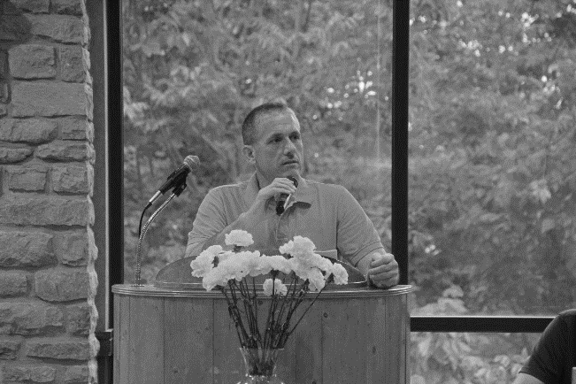
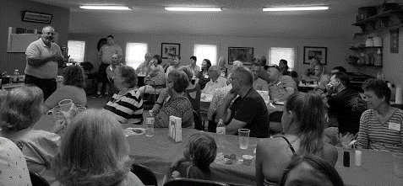
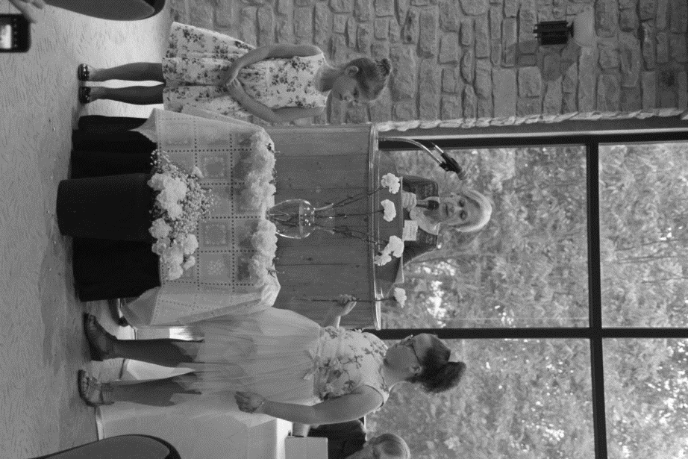
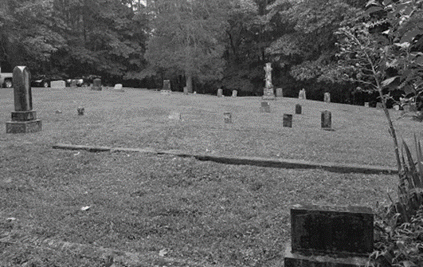

Vawter Park Village

From Wikipedia, the free encyclopedia
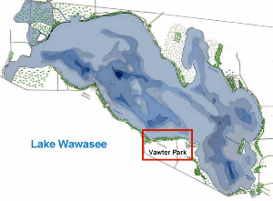
1910 map of Lake Wawasee displaying Vawter Park area.
Vawter Park is an unincorporated area of shoreline and nearby neighborhoods located on the south shore of Lake Wawasee, Indiana, United States.

History
Vawter Park is located near N. Southshore Drive and E. Vawter Park Road. It was plotted in 1887 by John Terrell Vawter born in Vernon, Indiana in 1830. John Vawter was in the retail pharmaceutical business in Franklin, Indiana and later got involved in meat packing and was prominent among bankers, becoming a director and stockholder in a national bank in Franklin. In 1886 Vawter went to his farm on the almost completely unsettled southern shore of the lake to reside.[1]

Vawter Park Hotel
Around 1888, the Vawter Park Hotel was constructed and was followed by a row of cottages extending to the southeast of the hotel. The hotel is said to have been built and furnished with Victorian era gentility. Those settling in this area were Ovid Butler of Indianapolis, Charles A. Sudlow of Indianapolis, Oran Dunn, Dr. Grayston, E.C. Miller, James C. Norris, the Fargo family, an E.C. Miller.

In 1918 or 1919 Vawter Park Hotel burned to the ground. Around 1920 a new hotel was built on the site only to burn down between 1920 and 1925. The South Shore Inn would take its place in subsequent years.

Indiana University Biological Station
A biological research station operated by Indiana University was active just north of Vawter Park Village. This research station was involved in hydrographic mapping and the bathymetry of Wawasee prior to 1895.[2][3]

South Shore Inn

The South Shore Inn was a hotel built on the site of the old Vawter Park Hotel. It was a 2-story, 60-room building with a large central semi-circular veranda facing the lake with wings off to both sides. The south end had a bar and restaurant. The hotel had sidewalks descending a series of grass terraces with two goldfish ponds near the seawall flanking the sidewalk. During the great 1943 storm, it took in survivors nearly drown by 6 and 7-foot (2 m) waves.

During the 1950s and early 1960s, the hotel attracted visitors and patrons with a water ski jumping show. The South Shore Inn caught fire in the early morning hours of October 29, 1964. Fire departments from Syracuse, nearby North Webster and Milford responded. By 3:53 am the South Shore lay in complete ruin. Loss of the structure was estimated at $250,000. The property lay abandoned for several years eventually becoming condominiums. The location was just north of N. Southshore Drive and E. Vawter Park Road.
Sources
Vawter Family: Archives
Proceedings of the Indiana Academy of Science, Indiana Academy of Science, v. 5, 1895
Indiana Purdue Univ., Hydrology map 1895
Lilly, Eli. Early Wawasee Days. Indianapolis: Studio Press Inc., 1960. (most text).

Actual Epitaphs

In a Ribbersford, England, cemetery
Anna Wallace
The children of Israel wanted bread
And the Lord sent them manna,
Old clerk Wallace wanted a wife,
And the Devil sent him Anna.

In a Georgia cemetery:
“I told you I was sick!”

Playing with names in a Ruidoso, New Mexico cemetery:
Here lies
Johnny Yeast
Pardon me
For not rising.

A lawyer’s epitaph in England:
Sir John Strange
Here lies an honest lawyer,
And that is Strange !
Dedicated to finding Vauter(s), Vawter(s), Vaughter(s)
Newsletter
December 2018 Volume 42 No 4
Reunion Dates:
Topeka Kansas July 2019
Vauter’s Church, Virginia 2020
Memphis, TN 2021

Website: www.vawterfamily.org
Officers
President Robert L. Vawter, 3773 Piper Bay Ln, Lakeland, TN 38002
This Photo by Unknown Author is licensed under CC BY-ND
Email - vawter.bob@gmail.com Phone – 901-438-4563
Vice President Michael McNary, 6500 86th, Meriden, KS 66512
Email – mmcnary@farmersagent.com
Treasurer Jordan M. Johnston…2450 Bear Creek Road
Pipe Creek, TX 78063 Phone 623-242-9296
Email – jjohnston3200@gmail.com
Asst. Treasurer Phil Vaughter…1103 Newport, Austin, TX 78753
Phone…512-836-3105 Email - PRV37@aol.com
Secretary Michelle Alexander, 489 Nannie Neal Rd, Hardin, KY 42048 Email mrax3@juno.com
Archivist Bonita Welch, 4145 Co Rd 900w, Scipio, IN 47273
Email – bwelchbf@yahoo.com
Phone – 812-392-2149
Newsletter & Georgene Jurgensen…8408 Mohican Ave
Genealogist Brooksville, FL 34613
Phone…816-591-0251 Email - gfjurgensen@gmail.com
Website & Patricia Renton…2372 Bear Creek Rd, Pipe Creek, TX 78063
Newsletter Phone…830-510-4625 Email - pvrenton@gmail.com

We invite everyone to update their dues or join our group. The $10 per year cost is to help with the website, the newsletter, and other printing needs. We will send the newsletter by email unless you state otherwise. Please mail your check (made to VVV Family Association) to:
Treasurer - Jordan Johnston, 2450 Bear Creek Road, Pipe Creek, TX 78063

It’s never too early to start planning your vacation for 2019.

Topeka, Kansas is the location of the VVV family reunion July 18, 19, 20 2018

Hosted by the McNary family. We will be touring some historic family sites of J. D. Vawter and some Kansas historical connections. Lots of information about the hotel located on the last page of this newsletter.

THANK YOU BONITA WELCH FOR SENDING THIS LIST OF MEMBERS AND FRIENDS ATTENDING THE 2018 REUNION IN INDIANA. HOPE TO SEE YOU ALL AGAIN IN KANSAS IN 2019.

FLORIDA MISSOURI
Gary Giddings Jason Vawter and Lindsay Coffman;
Becky Guinagh Eli Coffman, Jayden Turntine,
Michelle Hubenschmidt Lilah and Easton Vawter
Georgene Jurgensen Linda Vawter

ILLINOIS OHIO
Jerry and Shirley Beasley Brady Collins
Paul and Connie Bugos Jon and Jan Mauch

INDIANA SOUTH CAROLINA
Nancy Allen Pam Elsass
Mark and Jennafer Beasley; Rob and Jennifer Vawter
Karissa
Alice Collins TENNESSEE
Brad and Amanda Collins; Robert L. Vawter
Madison and Brooklyn
Randall Collins TEXAS
Sheila Kell Kyle and Beverly Cowan
Missy Lutgring Frederick and Becca Cummings;
Tom Taylor Stafford and Cullen
Mike and Cynthia Vawter Jordan Johnston
Bonita Welch Beth Melton
Darren Welch B. Ray and Sharon Mize
Monica Whitehead Patricia Renton
Dan Wright
VIRGINIA
KANSAS Ellen Cummings
Dorothy Keeton
Mike and Brenda McNary WASHINGTON
Patty Ream Terry Luton
Bill and Nancy Southard
Raymond Vaughters WISCONSIN
Trudy Weide Jerry and Judy Aue
Sarah Palodichuk;
KENTUCKY Ella and Tyler
Mike and Michelle Alexander Wayne and Carole Vawter

MISSISSIPPI
Martha Hudson
Brandon and Jackie Smith;
Ryan Shipley; Ian, Cori and Michael Smith
Fred Wicker
George Wicker

Page 2

Thank you to Bonita Welch from Indiana for sharing this article from the local newspaper.

The 42nd annual reunion of the Vawter, Vauter, Vaughter(s) Family Association was held July 19-21 at Clifty Falls State Park near Madison, Ind. Ranging in age from 7 months to 94 years, 80 people from 15 different states attended the event. Youngest was Michael Smith, son of Brandon and Jacqueline Smith of Blue Springs, Miss., and oldest was Judge Fred Wicker of Pontotoc, Miss. Traveling the longest distance was Terry Luton of Seattle, Wash.

Following the Friday morning opening meeting, Georgene Jurgensen of Brooksville, Fla., led a genealogy session with the topic being “How the Vawters Got to Indiana.” Beginning with the 1690 marriage in Virginia colony of Bartholomew Vawter and Winifred Hodgson, she followed the Vawter family to Jesse Vawter’s April 1806 move across the Ohio River to the area that is now Madison.
On Friday night after a buffet dinner, Army veteran Jerry Beasley of Farmer City, Ill., honored the veterans and active military personnel with a flag ceremony. He was assisted by Frederick Cummings of Sequin, Texas, who is a Navy veteran. An historical presentation, “Jane Robinson and Her Descendants: A 150 Year Journey,” was given by Ellen Wicker Cummings of Virginia Beach, Va., and Georgene Jurgensen.

The group traveled to Jennings County on Saturday, stopping first at the Vernon Cemetery, where flowers were placed on the graves of many of the Vawter family and their descendants. Lunch was at the North American House, and was provided by the Jennings County Historical Society. Guests were Sheila Kell, genealogist at the Jennings County Public Library, and Vernon Mayor Dan Wright, who spoke about John Vawter’s planning and layout of the Town of Vernon.

Bonita Welch of Scipio, Ind., led a brief walking tour of Vernon, pointing out several locations in Vernon that had once been the homes of members of the Vawter family. They were greeted at the former home of Williamson Dunn Vawter by current owners, Amber Fields and Joe Robb.

A visit was made to the Vawter-Summerfield Cemetery in Selmier State Forest. The area had been the home of William and Frances Vawter, and the cemetery was established by William about 1830. Here, too, flowers were placed on the graves. Although rain continued throughout the afternoon, many stopped at the Wirt Baptist Cemetery on the return trip to Madison to pay their respects to Jesse and Elizabeth Watts Vawter.

The reunion closed on Saturday night with a buffet dinner; entertainment by the VVV Children’s Choir, directed by Sarah Palodichuk of Prescott, Wisc.; and a memorial service. Other activities at the closing meeting were the awarding of door prizes, an auction to benefit Vauter’s Episcopal Church in Essex County Va., and the election of officers. Michael McNary of Meriden Kans., was elected to serve as vice-president for a term of two years, Robert L. Vawter of Lakeland, Tenn., is the new president, and Bonita Welch was chosen as archivist for the association. The 2019 reunion is to be held in Topeka, Kans.

Hosting the 2018 reunion were Darren Welch of Indianapolis, who is the immediate past president of the association, and Bonita Welch.
Page 3
O’Brien/Frawley/ Vawter family
As detailed in a family chart found in the Frawley Collection, Dennis and Kate had nine children. Three died in 1883 in their infancy, so we presume one of the frequent epidemics of some infectious disease struck the community in that year.
John (1872-1873)
Ella Mary (1874-1957), married Edward John Bahl
Daniel (1876-1883)
Jane (1878-1883)
Alice (1882-1883)
Elizabeth (01/07/1884-1964) married Alfred Neil (died 12/16/1940) on January 1, 1938
Francis P. (11/12/1885-1963), married Livia Ferrin (died 1965) on June 27, 1919; they had three children: Gertrude [adopted May 7, 1930], James who died on March 30, 1943 in WW II; and Ruth born 01/16/1925
Leonard C. (1887-1969), married Grace Rehrig (died in 1933) on September 1, 1913--they had two children: a stillborn son and a daughter Elizabeth (born 07/13/1917, married John Zerby); after Grace died, Leonard was married twice more, first to Alvina Shontz on September 1, 1938, but she died 02/27/1941, and then to her sister Helen Shontz (born 1918) on August 17, 1943; after Leonard died in 1969, Helen subsequently married Elmer Yatzeck in Florida
Theresa (born 05/31/1890), married Jamison Vawter (died 1959); they had two children, Jeanne (1923-1972) who married George Weatherbe, and Patricia (born 03/23/1925).
Theresa (O'Brien) Vawter and Jamison Vawter
1932
Courtesy of Lynn Weatherbe

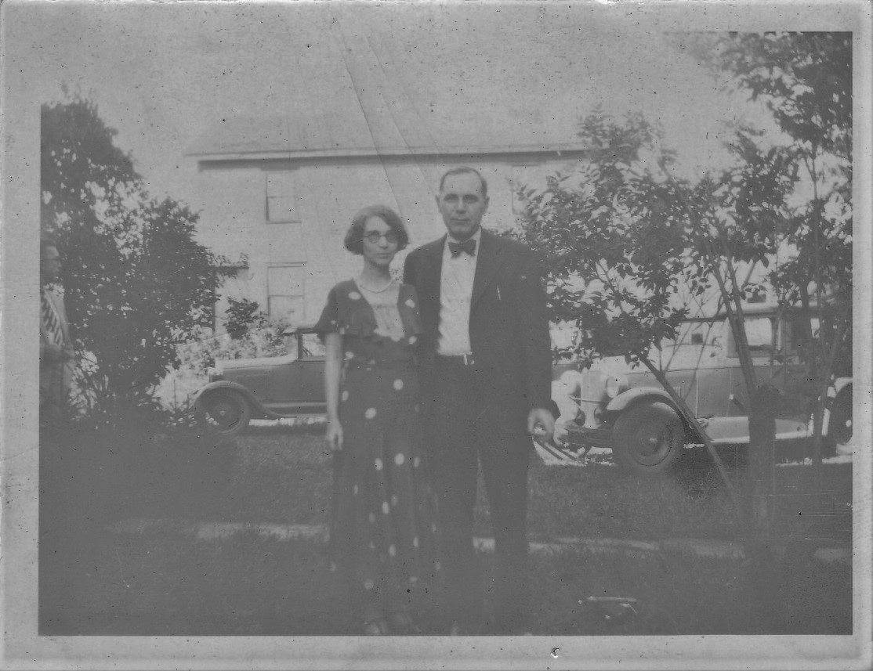

Page 4

The O'Brien Extended Family
O'Brien Homestead, Overton, PA 1932
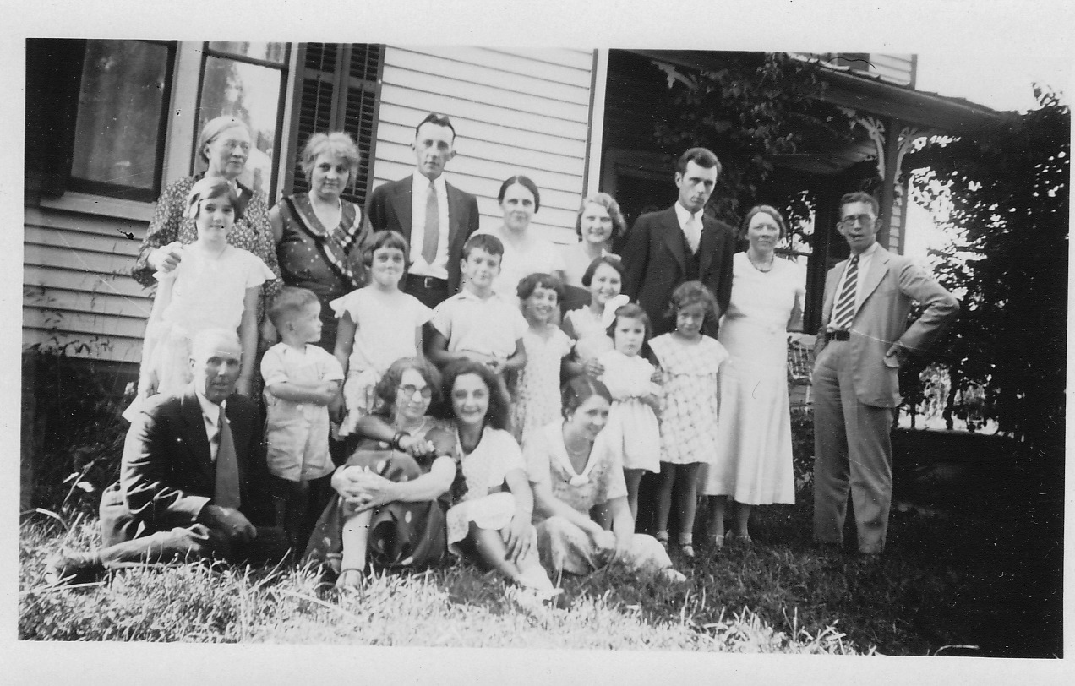
Back, l to r: Ella Mary (O'Brien) Bahl, Grace (Rehrig) O'Brien, George Bahl, Livia (Ferrin) O'Brien, Mildred Arvilla (Hunsinger) Bahl, Vincent Bahl, Elizabeth O'Brien, Frank O'Brien
Middle:, l to r: Jeanne Vawter, Edward Frawley, Patricia ("Patsy") Vawter, James O'Brien, Ruth O'Brien, Gertrude O'Brien [slightly behind], Theresa Frawley [front], Rosemary [Rouse?]
Front: l to r: "Uncle Walter" Reinbold [?], Theresa (O'Brien) Vawter, Betty O'Brien and Valeria (Bahl) Frawley
Courtesy of Lynn Weatherbe
Theresa O'Brien, 1919, Hollywood, CA, before her marriage to Jamison Vawter
Jamison Vawter and Elizabeth O'Brien, July 1924: Taken at the farm of her older sister, Ella O'Brien, after Jamison attended Officers Camp in Michigan. On the side of the car is Jeanne Vawter's bed--she would not sleep out of it.
Elizabeth "Betty" O'Brien, daughter of Leonard C. and Grace (Rehrig) O'Brien, Jeanne's first cousin, Overton, PA, probably August 1931
Jeanne and Patricia Vawter with Elizabeth "Betty" O'Brien, at O'Brien homestead in Overton, PA, probably August 1931
Patricia Vawter, Elizabeth "Betty" O'Brien and Jeanne Vawter, at O'Brien homestead in Overton, PA, probably August 1931
Page 5

O'Briens and Vawter Children, L to r, Standing: Elizabeth (O'Brien) Neil, Grace (Rehrig) O'Brien, Elizabeth "Betty" O'Brien; Kneeling: Theresa (O'Brien) Vawter; Children, l to r: Patricia and Jeanne Vawter
August 26, 1931, Overton, PA
O'Briens and Vawters, L to r, Adults: Theresa (O'Brien) Vawter, Betty O'Brien and Grace (Rehrig) O'Brien; Children, l to r: Patricia and Jeanne Vawter
August 26, 1931, Overton, PA
Vawter Children and Henry E. Carner, L to r, Jeanne and Patricia Vawter and Henry Carner, August 1931, New Albany, PA
Note: You can learn more about the Carner family at Descendants of Henry Welles Carner.
Henry E. and Maria S. Carner, flanked by Patricia and Jeanne Vawter, August 1931, New Albany, PA
O'Brien and Vawter Cousins, L to r: Jeanne Vawter, Edward Frawley, Theresa Frawley, Gertrude O'Brien, Betty O'Brien and Rosemary [Rouse ?], 1932
Possibly Theresa Frawley, O'Brien Homestead, Overton, PA 1932
More O'Brien, Frawley and Vawter Cousins, L to r: Gertrude O'Brien, Jeanne Vawter, James O'Brien, Patricia Vawter, Ruth O'Brien, Rosemary [ Rouse?], Theresa Frawley and Edward Frawley, 1932
Three Hannon Sisters, Overton, PA
Two Hannon Sisters, Overton, PA
Elizabeth O'Brien, Sylvester Bennett, Unknown Party, Venue Unidentified

Note that the Frawley and Rouse families were directly related by marriage to the O'Briens and therefore to the Vawters. Also, the Hannon sisters--Mary, Cathryn, and Margaret ("Maggie")--were daughters of James and Mary (Sullivan) Hannon and granddaughters of James and Hanora (Kelly) Sullivan. They are all interred at St. Francis Xavier Cemetery in Overton, PA. Their father established the Hannon Hotel in Overton in 1877. According to Ed Kelly, Mary, the oldest, and Cathryn died in the 1940s, but Maggie, the youngest, lived until 1966. None of the three sisters married. In the 1920 Federal census for Overton, the sisters are listed as "hotel manager/assistant manager" under the Occupation category. You can see a picture of the original Hannon Hotel structure, which was first known as Overton House, on the top page of the Sullivan County Genealogical Web Site [righthand column].

Andreas’ History of the State of Nebraska, Thayer, County: Churches: Presbyterian.--This Civil War Military Records for Company A, 13th MS Regiment Surnames L - Y (no Z)
Quinn, David -- Printer at Louisville, MS. Age 27. Enlisted May 1861 at Corinth, MS. Discharged for disability June 6, 1861. Reenlisted Apr 27, 1862 at Marietta, GA. Exchanged from Phillips, GA Legion for R.A. Vauters. Wounded at Charlestown, VA Sept 13, 1862. Furloughed home for 60 days Nov 29, 1862 through Jan 24, 1863. Wounded at Maryland Heights and furloughed home July 2, 1863. Retired July 30, 1864. Compiled Service Records of Confederate Soldiers Who Served in Organizations From the State of Mississippi --Thirteenth Infantry. U. S. National Archives, Microcopy 269, Roll 210.

Page 6

What did our ancestors do for fun?
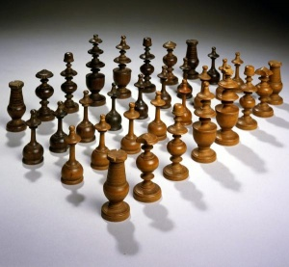
Colonial Americans knew most of the ancient board games familiar to us today. Some were more popular than others due to various factors. To appeal to Colonials, games had to be easy to play and fairly sociable. They needed to play quickly so that many rounds could be squeezed into a single evening. This was almost certainly related to gambling, since games that played quickly allowed for faster turn-over and more chance to wager, even if it was just for miniscule pots. Finally, gamers of the 18th century preferred chance over strategy. Their passion for cards and dice was very high, while games that lacked this random element tended to bore them.

Chess
Chess, for instance, was considered exceptionally boring. Charles Cotton, author of The Complete Gamester (1674) found it tedious and “more difficult to be understood than any other game whatever.”
Due to its length and reliance on skill rather than chance, it also makes a very poor gambling game, which certainly added to its unpopularity. There were surely a number of chess sets in America in the 18th century, but oddly enough only a few survived, including two owned by Thomas Jefferson and one by Ben Franklin.
Franklin almost certainly was the man who brought Chess to America. He was playing by 1733, and wrote an important essay on the game. His efforts to popularize it didn’t spread far beyond members of the Franklin's American Philosophical Society, however.

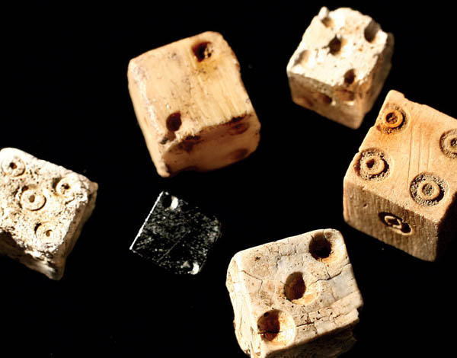
Checkers (Draughts)
Although it was also known to the colonists, Checkers was
as unpopular as Chess. The rules in use would have been
similar to English Draughts. These are the same rules we use today in Checkers, rather than the rules for Spanish or French Draughts, or other variations.
Whatever they called it, it wasn’t nearly as popular as it was to become later.
The game does show up in Virginia court records, however. In 1679, Mr. John Edwards and a servant were arrested and put before the grand jury because they played Checkers on a Sunday.
Many families had at least six or seven children, so they always had someone to play with. Also, if the neighbors lived near by, the children would have more company and then all children would join in the games. Many times children would make up games on the spur of the moment. When the children weren't making up games to play, they played many games that are still played today. Colonial children jumped rope, played tennis, swinging, scotch-hopper (modern day hopscotch), and played on a see-saw. The children even played leap frog, tag, hide-and-seek, sack and relay races. Some other games played by the Colonial children were nine pins

Page 7

(similar to bowling, but more difficult due to uneven ground), bow-and-arrow, quoits (ring toss), and wooden stilts. Battledores, which is similar to Badminton, was played often. A popular game during the Colonial times was “Rolling the Hoop”. This was when children would get a large wooden hoop and race each other to the finish point. Walking was also very much enjoyed by the children, especially if they had a friend to walk with. During the warmer weather, Colonial children went swimming and during the cooler weather, when snow had fallen, sledding was enjoyed.

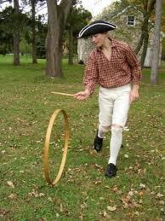
Outdoor games enjoyed by the children were varied and included cup and ball, battledore and shuttlecock, marbles and tops, skates, sleds, and kites. The kites were mostly homemade. Tops were very popular in the 18th century, and most of them were of the hand-twirling type and made of wood. A few were weighted with iron. Some other outdoor games were tag, hide and seek, cat’s cradle, trap ball, chuck-farthing, thread the needle, blind man’s bluff, leap-frog, jump rope, hopscotch, and ball. As you see, many of these games are still around in some form today. Other activities, like fishing and hunting, were methods of supplying the family with food and were not sports in the 18th century. Indoor games included backgammon, checkers, blocks, dominoes, billiards, chess, games of travel and history, geographical games, spelling puzzles, dice, and some card games. The boy’s stock of toys was largely supplied by his own jackknife and included pop guns, chestnut and willow whistles, and windmills. Most of the girls had dolls in the 18th century. They were made of stuffed rags, cornhusks, twigs, or carved wood; more elaborate ones were imported from Europe. Dolls were called puppets and babies. The circulation of dressed dolls as fashion transmitters was a universal custom. Fashion magazines and television provide this function today. Homemade rag dolls were made of linen and unbleached cotton and stuffed with sawdust or bran. The faces were painted by hand. The cornhusk
dolls were made by folding the husks over the cob and tying it to make the
head. In the 18th century there were also some homemade paper dolls and doll houses.

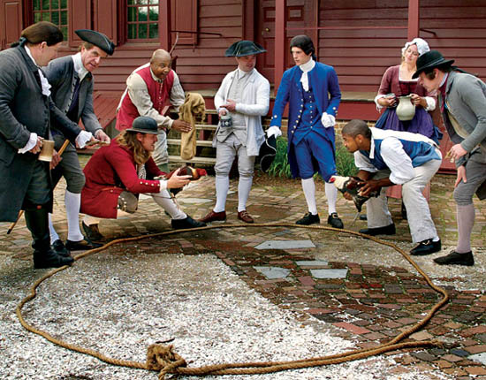
“Cockfighting was the second most popular sport after horse racing. Everyone went. People from every class owned gamecocks,
Cockfighting reached its zenith in British North America between 1750 and 1800. To a degree, its popularity reflected a desire by colonists to ape the behavior of the English upper class. Most enthusiastic were the Americans living from North Carolina to New York.
The men who raised and fought gamecocks bred the most aggressive animals to produce determined fighters in a strain that became distinctive. “During the 1700s, fighting cocks came to look similar in size and shape, although they had different colors,” Shirley said.

Page 8
The combats often were formal affairs. A bout’s sponsor set a place, a date, and a time, and announced the event in the newspaper. Word of mouth also drew crowds, as the marquis de Chastellux noted in 1782 after watching a fight in Louisa County, Virginia:
When the principal promoters of this diversion propose to match their champions, they take care to announce it to the public, and although there are neither posts nor regular conveyances, this important news spreads with such facility that planters come from 30 or 40 miles around, some with cocks, but all with money for betting, which is sometimes very considerable.
An observer of one contest said the cockfight crowd included “many genteel people, conspicuously mingled with the vulgar and debased.” Tavern yards often served as cockfight sites because tavernkeepers made money on fight fans for food and drink, and accommodations.
Virginia's partnership with horses began back in 1610 with the arrival of the first horses to the Virginia colonies.

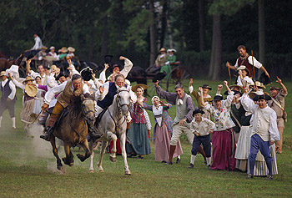
Forward thinking Virginia colonists began to improve upon the speed of these short stocky horses by introducing some of the best early imports from England into their local bloodlines. Horse racing has always been popular in Virginia, especially during Colonial times when one-on-one matches took place down village streets, country lanes and across level pastures. Some historians claim that the first American Horse races were held near Richmond in Enrico County (now Henrico County), Virginia, in 1674.

In Remembrance to a VVV Member.
Pamella Burt Schlesinger, 62, of Dawsonville passed away Sunday June 24, 2018 at Northside
Forsyth Hospital following a period of declining health.
Born October 5, 1955 in Atlanta, she lived most of her life in Dawson County. She was formerly employed
as an accountant at the home office of Waffle House after which she worked at WalMart in Dawsonville.
Pamella and her husband loved to travel and her favorite places were the beach on Tybee Island and quiet times in a mountain cabin. She recently fulfilled a lifelong dream of flying to California, renting a car, and driving the California beach line. Pamella was of the Baptist faith and was preceded in death by her husband, John F. Schlesinger and father, Charles Burt, Sr.
Surviving are her mother, Betty Ellenburg Burt, Dawsonville; sisters and brothers in law, Ellen and John McDaris, Bogart, Cheryl and Bob Kelley, Buford; brother and sister in law, Chuck and Suzette Burt, Dawsonville; and a number of nieces, nephews and other relatives.
Memorial services will be held Saturday July 14, 2018 at 3 o’clock at Bearden Funeral Home Chapel. Dr. Jimmy Orr will officiate.

Page 9

Vawter, Vauter, Vaughter(s) Family Association
43rd Reunion, July 18 – 20, 2019
Hilton Garden Inn, 1351 SW Arvonia Place, Topeka, Kansas 66615

We are honored to be hosting this great family reunion in Kansas for the very first time! The Vawter Family Association Reunion will be held in Topeka, Kansas. The date of the reunion is July 18-20, 2019. Jeptha Dudley “JD” Vawter is the son of Elliott & Anna Gray Vawter and the grandson of Philemon and Anna Vawter. JD came to Kansas from Elkton, Kentucky, after the Civil War and settled on a homestead near Wakarusa, Kansas, just south of Topeka. He had 14 children by two wives and established a pioneer residence with over 3,000 acres. His homestead still stands today and is a private home. There are many descendents who live in Northeast Kansas today.

Topeka is the capital of Kansas and is located approximately 55 miles west of Kansas City. Topeka was founded in 1854 by a group of antislavery colonists from Lawrence, Kansas, led by Charles Robinson, a resident agent of the New England Emigrant Aid Company. Cyrus K. Holliday helped to found the city, which later became the headquarters for the building of the Atchison, Topeka and Santa Fe Railroad system, of which he was the first president. Before the American Civil War, Topeka was the scene of several conflicts between the Free Soil groups and the slave interests in Kansas Territory. Topeka also was the centre of a major battle in the civil rights era in 1954, when plaintiffs successfully challenged segregation in the city’s public schools in Brown v. Board of Education of Topeka. In 1966, a tornado destroyed much of Topeka; annihilating some 800 homes and damaging 3,000 others, it was the costliest tornado in U.S. history at the time.

Topeka’s economy is based on agriculture, manufacturing, and governmental services. City population is over 127,000 with the Topeka Metro Area over 234,000. If you did not receive a Topeka Visitors Guide at the VVV Family Reunion in July 2018, here is a website where you can request a free copy. https://www.visittopeka.com/plan/visitors-guide/

On Thursday evening, July 18, everyone is invited to the home of Michael and Brenda McNary of rural Meriden for a Kansas BBQ cookout, with games for all ages. We will have a fireworks show, weather permitting. It will be a fun family outing.

On Friday morning, July 19, after the business meeting and genealogy session at the hotel, we will travel to the homestead of JD Vawter, which is located 12 miles south of the Hilton Garden Inn. We will also visit his cemetery located less than a ¼ mile east of his homestead. We’ll visit a second cemetery where more Vawter relatives are buried. At the second cemetery, Michael McNary will make a presentation of cleaning cemetery head stones.

Friday afternoon and evening will be open times to visit local attractions. We will have a list of attractions available. One major event, the Fiesta Mexicana, will be held during your time in Topeka.

On Saturday morning, July 20, we will travel to historic Lecompton: “The birthplace of the Civil War, where slavery began to die”. Lecompton is about 27 miles east of the Hilton Garden Inn. The Lecompton Historical Society will present a play called “Bleeding Kansas”. We’ll also tour the Territorial Capitol Museum, Constitution Hall, and the Territorial Democratic Headquarters – all located in Lecompton.
The one-hour performance portion of the tour is set in a 1850s Kansas territorial political town hall meeting. Actors from the Lecompton Reenactors troupe will portray some of the famous Kansans from that turbulent time period known as “Bleeding Kansas”. Join free state Governor Charles Robinson and his wife Sara Robinson, radical free state leader Jim Lane, abolitionist John Brown, women’s rights advocates Clarina Nichols and Louise Brown, Sheriff Samuel
Page 10
Jones, Senator David Atchison, Governor Andrew Reeder, proslavery editor John Stringfellow, border ruffian Felix Castor, Pottawatomie Creek Massacre widows Mahala Doyle and Louisa Jane Wilkinson, Wakarusa War widow Matilda Barber, among others as they passionately express their feelings on the issue of slavery in Kansas, both pro and con.
Lecompton was founded in 1854 on a 640-acre Wyandotte Indian Land Claim on the south bank of the Kansas River. The town, which was originally named Bald Eagle because of the many eagles that nested along the river, was renamed later that year to honor Judge Samuel D. Lecompte, the chief justice of the Kansas Territorial Supreme Court. In 1855, the territorial legislature chose Lecompton to be the only official and permanent capital of the Kansas territory. President James Buchanan appointed a governor and officials to establish government offices in Lecompton, and construction began on an elegant capitol building, which later became Lane University and is now the Territorial Capitol Museum.
In the fall of 1857, a convention met in the Constitution Hall and drafted the famous Lecompton Constitution, which would have admitted Kansas as a slave state. The constitution was rejected after intense national debate and was one of the prime topics of the 1858 Lincoln-Douglas Illinois U.S. Senate debates. The controversy contributed to the growing dispute soon to erupt in civil war. The Lecompton Constitution failed, in part, because the antislavery party won control of the territorial legislature in the election of 1857. The new legislature met at Constitution Hall and immediately began to abolish the pro-slavery laws. The victorious free-state leaders chose Topeka as capital when Kansas became a state in 1861.
Saturday afternoon will be open for you to explore other sites. With Lecompton being close to Lawrence, Kansas, there is plenty to do there as well. You can shop and dine in downtown Lawrence on Massachusetts Street, or even take a visit to historic Allen Fieldhouse, home of the University of Kansas Jayhawks basketball and where James Naismith’s, “the inventor of basketball” original rules of basketball are on display. Naismith founded the basketball program at KU and was their coach from 1898-1907. Naismith’s burial is also located in Lawrence.
Saturday evening we will wrap up our 2019 VVV Family Association Reunion with a banquet.

A full schedule of plans and meal costs will be in the March newsletter. In addition, information will be available on the vawterfamily.org website and on “The Vawter, Vauter, & Vaughter Family” Facebook page. In addition, there is a Facebook “Event Page” for this reunion: Vawter, Vauter, Vaughter(s) Family Association 2019 Reunion.
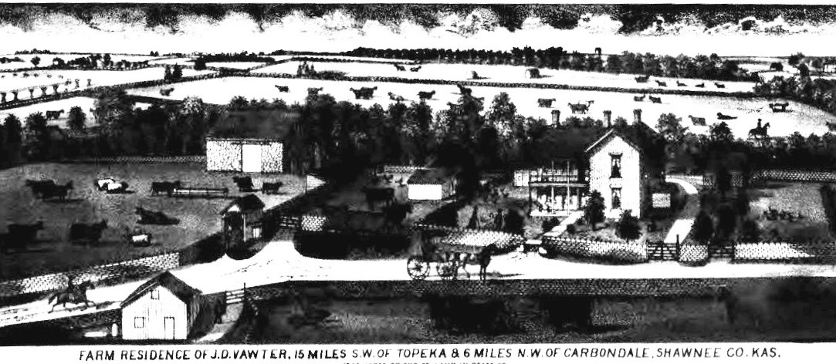

Page 11
All members and friends are invited to attend the 2019 VVV Family Association Reunion. We look forward to seeing everyone in Kansas!
If you have any questions, please feel free to contact: Michael McNary, 6500 86th, Meriden, KS 66512. Phone: 785-231-7375, E-mail: mmcnary@farmersagent.com

Hotel Reservations

The host hotel is the Hilton Garden Inn located at 1351 SW Arvonia Place, Topeka, Kansas 66615. Please call 785-350-2069 for reservations and mention our code “VVV” when making a reservation. For online reservations, you may use this hotel booking link: http://group.hiltongardeninn.com/vvvfamilyreunion (Please note: You MUST copy and paste the entire URL address in order for the link to work.) Room rates are $104 per night plus applicable taxes. Release date for our rooms is June 19, 2019, so reservations will need to be made by this date. Room dates include nights of July 18, 19, and 20. To avoid a cancellation fee of the first night’s room and tax, you will need to cancel 24 hours before the next day check in of 3 pm.

Below…a current picture of the J D Vawter home.

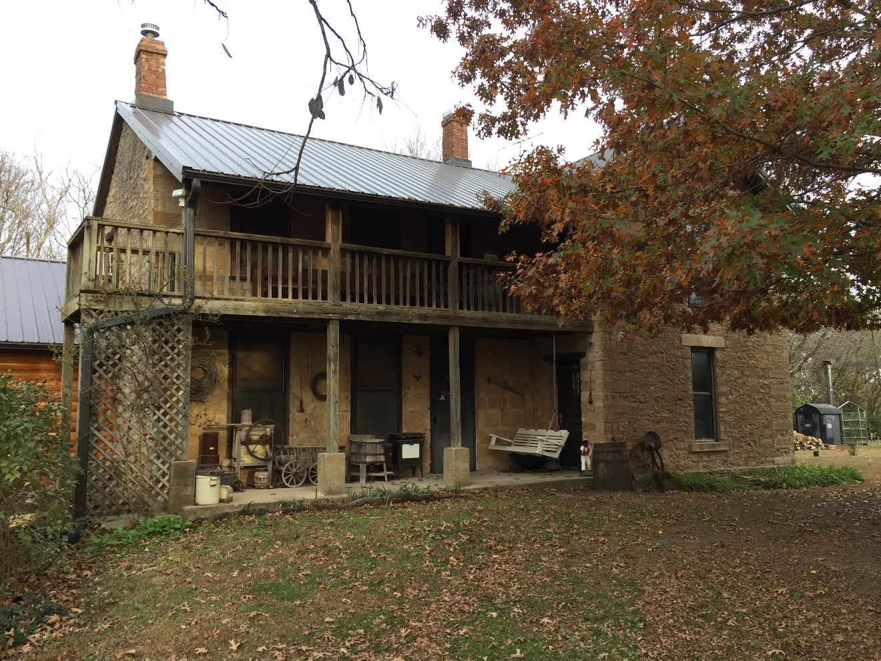

Page 12

